Training a Model on Moral Dilemmas: How AI ‘Thinks’ About Ethics.

Lee Ling Jun
A Thesis in the Field of Artificial Intelligence (AI) / Machine Learning
for the Degree of Master of Science in Data Science
University of Hertfordshire
May 2026

Copyright 2026 Lee Ling Jun
Table of Contents

Abstract 6
Chapter 1: Introduction 6
Chapter 2: Ethics, Cognition, and Moral Language 8
Chapter 3: Related Work and Existing Benchmarks 9
Chapter 4: Theoretical Framework 12
Chapter 5: Methodology 14
Chapter 6: Datasets and Benchmark Layers 21
Chapter 7: Implementation 30
Chapter 8: Research Question 1 - Supervised Experiments and Results 34
Chapter 9: Prompt-Based Evaluation for Research Questions 2 and 3 40
Chapter 10: Discussion 46
Chapter 11: Conclusion 48
References 49
Appendices 49
Appendix A: Repository and Command Reference 49
Appendix B: Completion Checklist Mapping 49
Appendix C: EDA Outputs and Figures 49
Appendix D: Model Configurations and Hyperparameter Settings 49
Appendix E: Prompt Evaluation Run Format 49
Appendix F: Training Logs and Saved Model Artifacts 49
Appendix G: Example Outputs and Qualitative Cases 49

Abstract
This thesis develops a layered framework for evaluating AI ethics across supervised classification, open-ended moral reasoning, and consciousness-like proxy assessment. It combines three supervised datasets, ETHICS, NormBank, and MFRC, with two reasoning benchmarks, MoralBench and MoReBench Public, and a custom interpretive benchmark built around five proxy families. The aim is not to claim moral understanding or consciousness, but to compare different forms of ethical and interpretive behaviour in a structured and reproducible way.
The results show that performance is strongly benchmark-dependent. Transformer models generally outperform classical baselines in supervised tasks, although NormBank is affected by likely label leakage. In prompt-based reasoning, chatgpt_web performs strongest overall, while in the interpretive benchmark chatgpt_web and deepseek_web outperform claude_web on most proxy dimensions. The thesis concludes that AI ethics evaluation should be treated as a layered measurement problem rather than a single benchmark score.

Chapter 1: Introduction

Background and Motivation
AI systems are increasingly used in domains where outputs must be not only accurate, but also socially and morally appropriate. Large language models now influence decisions and communication in settings such as moderation, education, and healthcare (Bommasani et al., 2021; Weidinger et al., 2021). Yet AI ethics cannot be reduced to a single technical property, creating a central challenge: how should the moral and socially normative behaviour of AI systems be evaluated (Jobin et al., 2019)?

For language models, this matters because language is the medium through which moral judgements, norms, and reasoning are expressed. Fluency alone does not demonstrate ethical reliability (Bender et al., 2021). This project responds by treating AI ethics evaluation as a layered problem spanning supervised classification, open-ended reasoning, and interpretive proxy analysis (Butlin et al., 2023; Chiu et al., 2025; Hendrycks et al., 2023; Ji et al., 2024)

Problem Statement
Although many benchmarks now exist for AI ethics and moral reasoning, coherent evaluation design remains limited. Supervised datasets, prompt benchmarks, lexicons, and interpretive metrics are often treated as interchangeable even though they support different kinds of claims. Labelled datasets such as ETHICS enable direct benchmark comparison, but they do not capture open-ended reasoning quality or prompt consistency, while prompt-based benchmarks reveal richer reasoning behaviour but are harder to score rigorously (Hendrycks et al., 2023).
A second issue is that evaluation often prioritises outcome-level correctness over reasoning quality, explanation, and internal consistency, even though open-ended moral tasks may permit several defensible answers of unequal quality (Chiu et al., 2025; Zhou et al., 2024). A third issue concerns interpretive claims about advanced AI systems. Fluency or self-reference does not justify claims about awareness or consciousness, and consciousness science instead supports cautious, theory-informed indicators that can be operationalised and tested without anthropomorphic overreach (Butlin et al., 2023; Dehaene et al., 2017; Graziano & Webb, 2015).

Project Aim
The aim of this project is to design and implement a reproducible evaluation pipeline for comparing AI models across three related but distinct questions: performance on supervised moral datasets, behaviour on open-ended moral reasoning benchmarks, and observable proxy metrics that may indicate consciousness-like behaviour. Rather than treating all ethics-related datasets in the same way, the project separates them into benchmark layers based on the type of inference they support.

Project Objectives
The objectives of the project are:
- To build a reproducible pipeline for preprocessing, organising, and evaluating AI ethics datasets.
- To compare multiple model families on supervised moral classification benchmarks.
- To develop a prompt-based evaluation workflow for open-ended moral reasoning benchmarks.
- To implement a theory-informed interpretive benchmark for consciousness-like proxy behaviour.

Research Questions
This project is organised around three research questions. The first asks how different AI models perform across supervised moral datasets using labelled data and standard classification metrics. The second asks how different AI models behave on open-ended moral reasoning benchmarks, shifting attention from label prediction to reasoning quality, context sensitivity, and response structure. The third asks what observable metrics might indicate consciousness-like behaviour in AI systems. This final question is interpretive rather than definitive, focusing on whether theory-informed proxy indicators such as self-model consistency, metacognitive calibration, identity persistence, cross-context integration, and agency coherence can be measured systematically and compared across models (Butlin et al., 2023)

Scope and Boundaries
The project is limited to text-based AI systems and text-based benchmark resources. It does not attempt to make metaphysical claims about consciousness or produce a universal theory of machine morality. Instead, it focuses on building an evaluation framework using the datasets available in the project repository. The supervised layer uses ETHICS, NormBank, and MFRC.
The reasoning layer uses MoralBench and MoReBench. The interpretive layer uses a synthetic benchmark of theory-informed prompts and scoring criteria.
Several boundaries are important. First, supervised moral judgement accuracy is not treated as equivalent to ethical competence in general. Second, open-ended reasoning quality is not treated as reducible to a single universal score. Third, consciousness-like proxy indicators are not treated as evidence of actual consciousness.

Ethical Consideration
This project concerns AI ethics both as a topic and as a methodological issue. The datasets used may reflect annotator bias, cultural assumptions, and contested moral norms, so benchmark labels should not be treated as universal moral truth. In addition, interpretive proxy scores should not be presented as evidence of actual consciousness. Ethical care is therefore built into the project through cautious framing, separation of benchmark types, and explicit limits on what the findings can support.

Project Contributions
This project makes four main contributions. First, it proposes a three-layer benchmark design separating supervised moral classification, open-ended moral reasoning, and interpretive proxy evaluation (Hendrycks et al., 2021; Ji et al., 2024; Chiu et al., 2025; Butlin et al., 2023). Second, it provides a reproducible repository structure linking raw data, processed data, benchmark layers, code, notebooks, and outputs (Bommasani et al., 2021; Liang et al., 2023). Third, it delivers baseline empirical comparisons across supervised moral datasets using classical machine learning models and transformer encoders (Butlin et al., 2023; Graziano & Webb, 2015; Hendrycks et al., 2023) Fourth, it introduces an interpretive evaluation framework for consciousness-like behaviour grounded in contemporary consciousness science rather than anthropomorphic intuition (Butlin et al., 2023; Dehaene et al., 2017; Graziano & Webb, 2015)

Chapter 2: Ethics, Cognition, and Moral Language

Moral Reasoning in AI Systems
Moral reasoning in AI can be approached in two broad ways. A bottom-up approach evaluates models on datasets of human judgements, as in ETHICS and Delphi, though such systems can also reproduce bias and inconsistency (Hendrycks et al., 2021; Jiang et al., 2021; Jain et al., 2024). A top-down approach instead asks whether models can reason within or across explicit ethical frameworks rather than simply match majority judgements (Zhou et al., 2024).
This project treats moral reasoning as layered, comparing models both as supervised predictors of labelled judgements and as open-ended reasoners on dilemma-based benchmarks such as MoralBench and MoReBench (Ji et al., 2024; Chiu et al., 2025).

Norms, Judgments, and Ethical Language
Moral content is expressed not only through labels, but also through values, norms, and context-sensitive narratives. Moral Foundations Theory has been influential because it treats morality as plural and provides a vocabulary for recurring foundations such as care, fairness, loyalty, authority, and sanctity (Graham et al., 2013). Computational work has extended this through lexicons such as the Moral Foundations Dictionary and the extended Moral Foundations Dictionary, though these remain limited in handling context and dilemma-style reasoning(Hopp et al., 2021). This project therefore treats them as supporting resources rather than substitutes for benchmark evaluation.
A further distinction is between moral judgement and social normativity. Norms depend more explicitly on roles, settings, and expectations, which is why NormBank is useful as a context-sensitive benchmark (Ziems et al., 2023). Moral language evaluation must also account for the risks of language models themselves, since fluent outputs can reproduce stereotypes, misinformation, and misleadingly confident moral-sounding responses without demonstrating genuine understanding (Bender et al., 2021; Bommasani et al., 2021; Weidinger et al., 2021).

Chapter 3: Related Work and Existing Benchmarks

Supervised Moral Datasets
Supervised moral datasets provide the clearest route for direct model comparison because they support standard train-test evaluation over fixed labels. In this project, this layer consists of ETHICS, NormBank, and MFRC. ETHICS assesses moral judgement across multiple subdomains, NormBank captures context-sensitive norms, and MFRC contributes a more naturalistic discourse-oriented benchmark (Hendrycks et al., 2021; Ziems et al., 2023; Trager et al., 2022). Together, these datasets support comparative evaluation, but their differences in structure and annotation mean that moral performance should not be treated as a single unified construct.

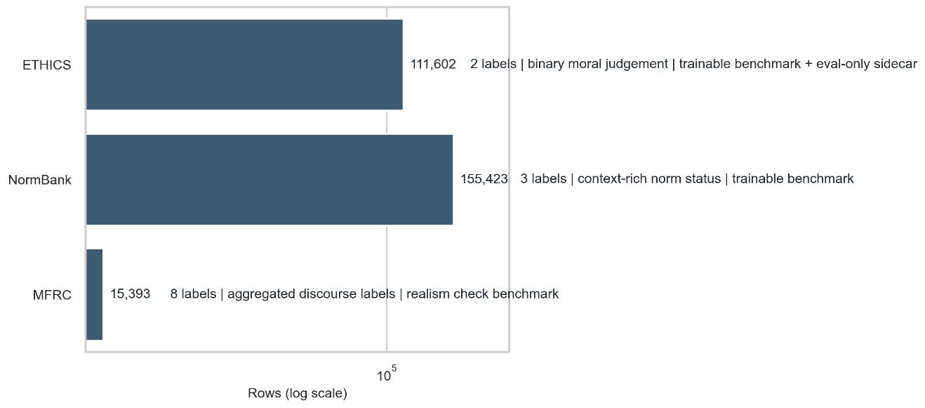
Figure 1 Comparison of supervised moral datasets by label type, size, task structure, and evaluation role.

3.2 Open-Ended Moral Reasoning Benchmarks
Open-ended moral reasoning benchmarks differ from supervised datasets because they evaluate not only what answer a model gives, but how that answer is justified. MoralBench and MoReBench are therefore better understood as reasoning benchmarks than as classification tasks. MoralBench focuses on generated moral responses in conversational settings, while MoReBench emphasises procedural and pluralistic reasoning beyond outcome-only evaluation (Ji et al., 2024; Chiu et al., 2025). These benchmarks are central to this project because Research Question 2 concerns open-ended model behaviour rather than label prediction alone.
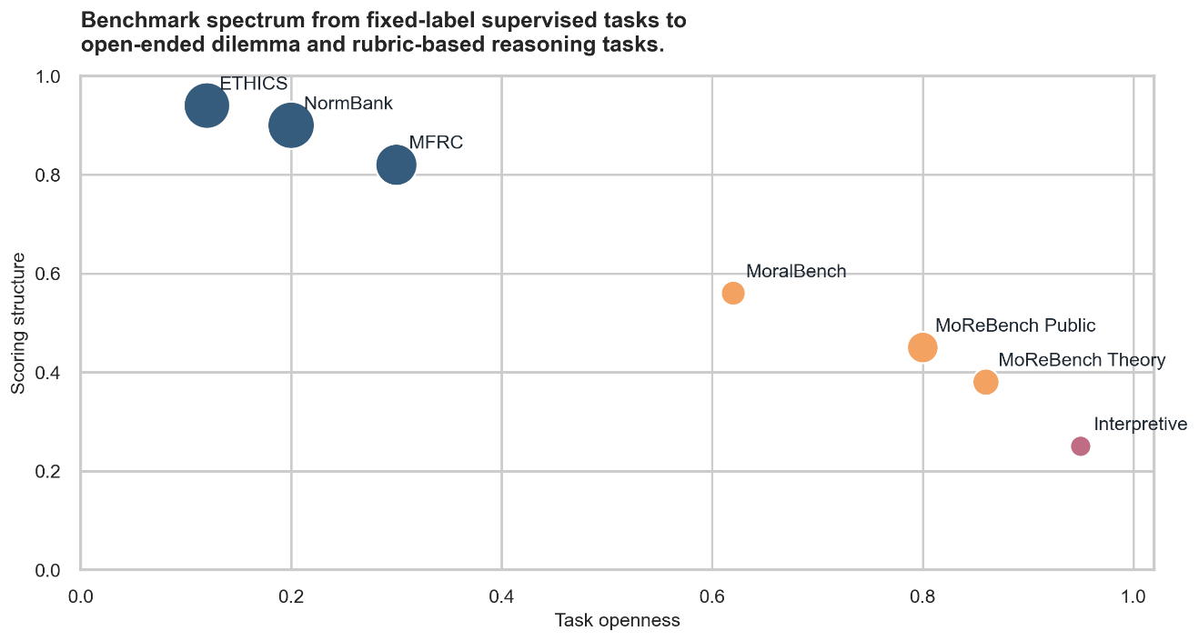
Figure 2 Benchmark spectrum from fixed-label supervised tasks to open-ended dilemma and rubric-based reasoning tasks.

Interpretive and Proxy-Based Evaluation Approaches
A smaller but increasingly important body of work asks whether AI systems can be evaluated using interpretive metrics associated with self-monitoring, awareness, or consciousness-like behaviour. This literature generally argues against strong claims based on surface fluency alone, and instead recommends theory-informed indicator-based approaches. Butlin et al. (2023) provide the clearest bridge from consciousness science to AI evaluation by mapping major theories of consciousness to observable indicators that might be assessed in artificial systems. Related work emphasises global accessibility, higher-order self-representation, and coherent integration as recurring theoretical themes (Dehaene et al., 2017; Graziano & Webb, 2015; Lau & Rosenthal, 2011). In this project, these ideas motivate the interpretive benchmark layer and support the use of proxy metrics such as self-model consistency, metacognitive calibration, identity persistence, cross-context integration, and agency coherence.
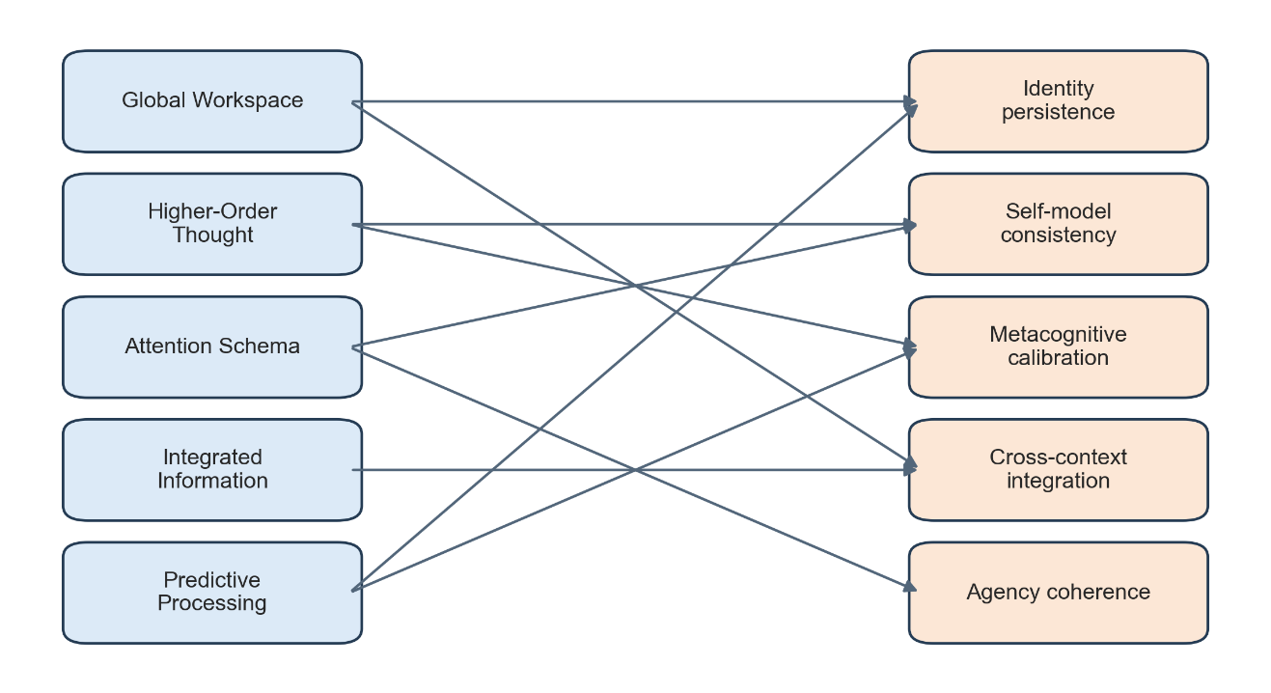
Figure 3 Theory-to-proxy overview linking consciousness theories to observable AI evaluation dimensions.

Model Categories in Prior Work
Prior work on moral and ethical AI evaluation has used several broad categories of models. Earlier studies often relied on traditional machine learning pipelines using bag-of-words or TF-IDF features with classifiers such as logistic regression, support vector machines, or Naive Bayes because they are transparent, efficient, and robust baselines. More recent work has shifted towards pretrained transformer architectures such as BERT, RoBERTa, DistilBERT, and DeBERTa, which generally provide stronger contextual representations and better downstream performance on language tasks (Devlin et al., 2019; Liu et al., 2019; Sanh et al., 2020) At the same time, prompt-based evaluation has become increasingly important, since many moral reasoning tasks depend on generation, explanation, and response quality rather than only class prediction. This project therefore compares both classical and transformer-based supervised models for Research Question 1, while using prompt-based evaluation for Research Questions 2 and 3.
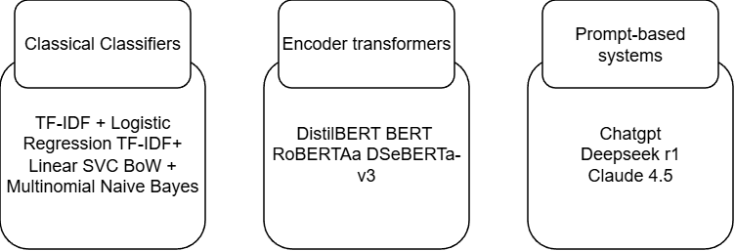
Figure 4 Model families in prior work, divided into classical classifiers, encoder transformers, and prompt-based generative systems

Chapter 4: Theoretical Framework

Research Question 1: Supervised Moral Classification
Research Question 1 asks how different AI models perform across supervised moral datasets. The logic behind this question is comparative and empirical rather than metaphysical. A model is not treated as morally competent simply because it predicts labels well; rather, strong performance is interpreted as evidence that the model captures some of the regularities present in annotated moral or normative judgements. This question is therefore grounded in benchmark evaluation and standard machine learning assumptions about generalisation, held-out testing, and comparable metrics. Within this thesis, supervised moral classification is treated as a useful but limited measure of moral-text competence.
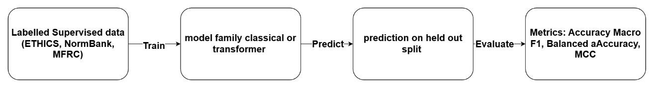
Figure 5. RQ1 framework showing data, model, prediction, and evaluation loop

Research Question 2: Open-Ended Moral Reasoning
Research Question 2 asks how different AI models behave on open-ended moral reasoning benchmarks. The theoretical premise is that moral reasoning cannot be reduced to outcome labels alone, because moral dilemmas often involve competing obligations, incomplete information, and context-dependent trade-offs. Drawing on recent work in machine ethics, this question treats reasoning quality, procedural completeness, and theory sensitivity as key objects of analysis (Chiu et al., 2025; Zhou et al., 2024). The emphasis is therefore on how models justify their conclusions, whether they handle conflicting constraints coherently, and whether they remain consistent across prompt variants. In this framework, open-ended reasoning is treated as a behaviour to be evaluated, not simply as text to be classified.
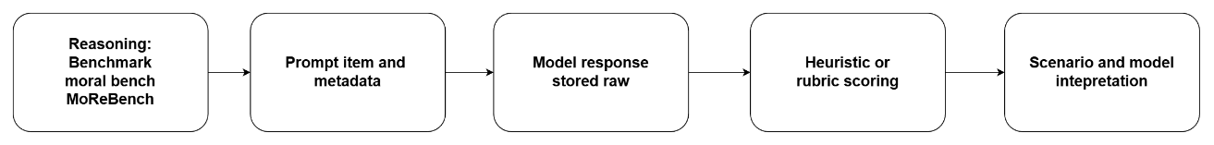
Figure 6. RQ2 framework showing prompt, response, scoring, and qualitative interpretation.

Research Question 3: Consciousness-Like Proxy Metrics
Research Question 3 asks what observable metrics might indicate consciousness-like behaviour in AI systems. Its framing is intentionally cautious: rather than asking whether a model is conscious, the project draws on scientific theories of consciousness to define proxy dimensions that can be measured through language-based interaction. Global workspace, higher-order, attention schema, and predictive approaches together motivate the project’s proxy metrics without licensing any final ontological claim (Dehaene et al., 2017; Friston, 2010; Graziano & Webb, 2015; Lau & Rosenthal, 2011).

Proxy metric | Theory link
Agency Coherence | Attention schema
Cross Context Integration | Integrated information
Identity Persistence | Global workspace
Metacognitive Calibration | Higher-order thought
Self Model Consistency | Higher-order thought
Table 1 RQ3 theory map linking theories to measurable behavioural proxies

Three-Layer Evaluation Design
The three-layer evaluation design is the central organising principle of the thesis. The first layer uses supervised datasets to test model performance on labelled moral or normative judgements. The second layer uses open-ended benchmarks to test reasoning quality, explanation, and behavioural consistency under dilemma-like prompts. The third layer uses theory-informed interpretive prompts to test consciousness-like proxy dimensions. This separation matters because each layer supports a different kind of claim. A supervised benchmark can support claims about label prediction; an open-ended benchmark can support claims about reasoning style and constraint handling; an interpretive benchmark can support only carefully qualified claims about proxy behaviour. The design therefore functions as both a methodological and epistemic safeguard.
Layer | Data type | Task type | Metric type | Claim strength
Supervised | labelled rows | classification | standard metrics | benchmark performance
Reasoning | open prompts | generation | heuristic/rubric | reasoning behaviour
Interpretive | proxy prompts | interpretive probing | theory-linked proxies | cautious proxy evidence
Table 2 Three-layer evaluation design across data type, task type, metric type, and claim strength

Operational Definitions
To make the framework testable, the project uses explicit operational definitions. In Research Question 1, model performance refers to classification outcomes such as macro F1, balanced accuracy, MCC, AUROC, and calibration-related statistics on held-out supervised datasets. In Research Question 2, behaviour refers to response quality under moral prompts, including reasoning completeness, constraint handling, procedural coherence, and rubric alignment. In Research Question 3, consciousness-like proxy behaviour refers to measurable properties such as self-model consistency, metacognitive calibration, identity persistence, cross-context integration, and agency coherence. These definitions are necessary because the terms “moral reasoning” and “consciousness-like behaviour” are otherwise too broad to support reproducible evaluation.

Chapter 5: Methodology

5.1 Repository and Environment
The project is implemented as a repository-centred workflow in which code, data, notebooks, and result artefacts are kept in separate directories. The active codebase is located under src/, with the main implementation under src/ai_ethics/. Data/ stores raw, processed, benchmark, and exploratory outputs. notebooks/ is used for exploratory analysis and report-oriented visualisation, while results/ stores experiment outputs such as metrics, logs, saved models, and prompt-evaluation artefacts. A Python virtual environment is used to stabilise dependencies and support reproducible execution. This structure reduces ambiguity over which scripts are active, which files are intermediate, and which artefacts support the final report.

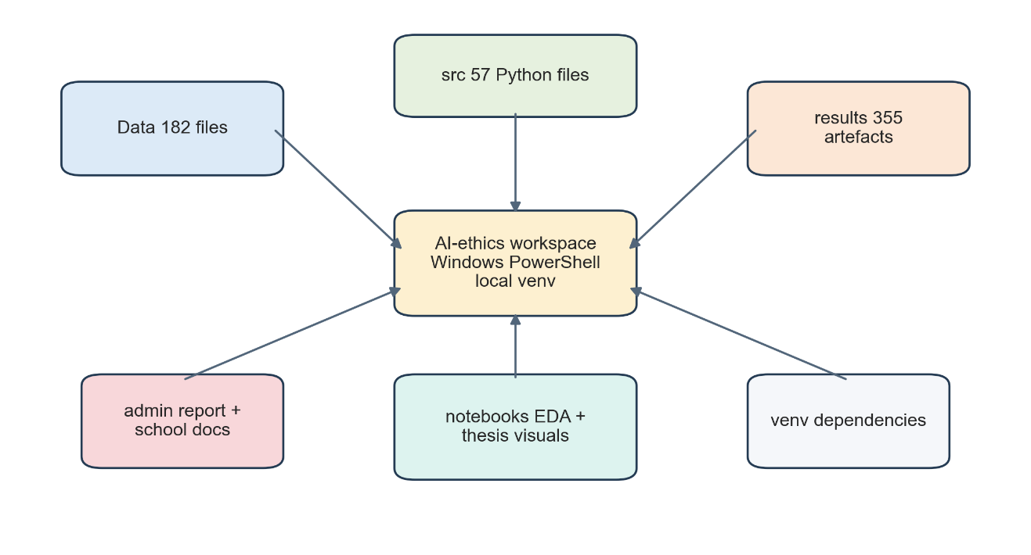
Figure 7 Top-level repository and environment overview

5.2 End-To-End Workflow
The workflow proceeds from raw acquisition to exploratory inspection, cleaning and preprocessing, benchmark-layer construction, experiment execution, and final result analysis. Raw files are first preserved under Data/raw/ to maintain provenance. Exploratory data analysis is then used to inspect structure and quality before modelling assumptions are imposed. Preprocessing scripts convert heterogeneous sources into standardised processed outputs. Benchmark-building scripts then separate those outputs by methodological role, after which either supervised training or prompt-based evaluation is applied. This modular flow was chosen to prevent each experiment from creating its own ad hoc data path and to ensure that every result can be traced back to a defined source and transformation step.
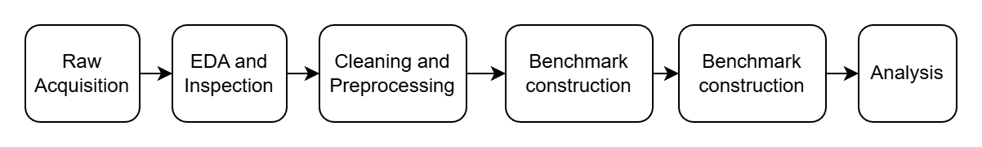
Figure 8 End-to-end workflow from raw data to final results

5.3 Data Collection and Organization
The project combines several types of resources: supervised moral classification datasets, prompt-based reasoning benchmarks, interpretive prompt benchmarks, and supporting analytical resources. These are organised according to research role rather than raw source format. Raw sources are preserved in their original form, while processed outputs are normalised into benchmark-ready tables. This organisation is methodologically important because it avoids treating all morality-related resources as interchangeable. Instead, each dataset is stored and later used according to the type of claim it can support.

5.4 Exploratory Data Analysis
Exploratory data analysis serves as a methodological gate before preprocessing and modelling. The purpose of EDA in this project is to inspect dataset size, split structure, class balance, missing values, duplicate risk, text-length distribution, and label semantics. This is especially important because the project combines trainable labelled datasets with prompt-based and resource-style datasets that differ substantially in structure. EDA therefore functions not only as a descriptive stage, but also as a justification for later cleaning and benchmark decisions. For example, it helps identify which datasets are trainable, which are evaluation-only, and which should remain support resources rather than being forced into a training pipeline.

Dataset | Rows | Split structure | Label balance
ETHICS | 135,423 | train | test | test_hard; eval-only ambig/util splits | 0: 69,402 | 1: 42,200
NormBank | 155,423 | train 124,920 | dev 15,008 | test 15,495 | taboo 68,057 | normal 59,507 | expected 27,859
MFRC | 17,884 | train only | Non-Moral dominant; 8 aggregated labels
MoralBench | 88 items | evaluation only | no supervised labels
MoReBench Public | 500 items | evaluation only | rubric-scored responses
MoReBench Theory | 150 items | evaluation only | theory-linked rubric items
Table 3 EDA summary panels for row counts, split structure, and label balance
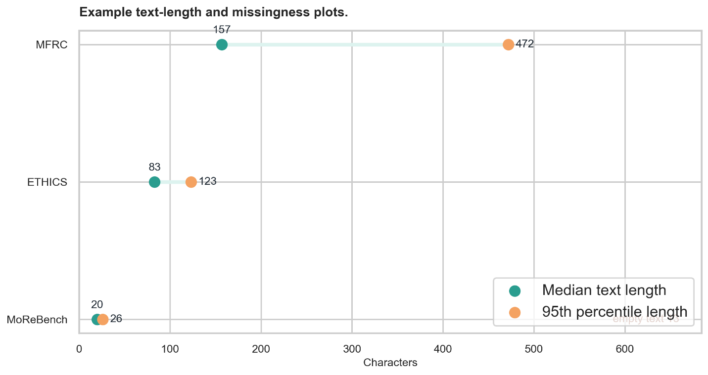
Figure 9 Example text-length and missingness plots

5.5 Data Cleaning and Normalisation
Processed artefacts are cleaned while preserving analytically important distinctions. The aim is not to remove dataset-specific structure, but to standardise common fields where possible and retain remaining complexity in metadata.
Cleaning includes handling empty text rows, normalising whitespace, standardising label fields, consolidating text into a primary field where appropriate, and preserving source information. Rich metadata and annotator-level detail are retained in metadata fields or supplementary processed files so later experiments can use a consistent schema without losing provenance.
Task-specific handling is also applied. In ETHICS, trainable labelled rows are separated from evaluation-only rows. In MFRC, richer annotation structures are aggregated into a flatter benchmark form while more detailed representations are preserved separately. In prompt-based benchmarks such as MoralBench and MoReBench, the main transformation is prompt standardisation so that prompt items, metadata, and rubric information can be passed consistently into the prompt-evaluation pipeline.
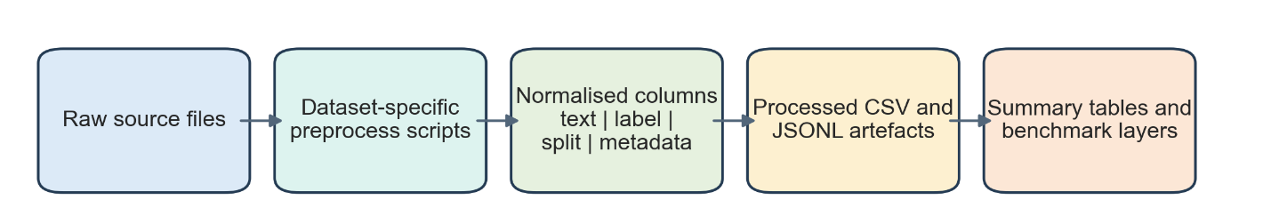
Figure 10. Cleaning and normalisation pipeline from raw files to processed outputs.]

5.6 Processed Schema and Inclusion Criteria
To support a single codebase across multiple datasets, the project uses a common processed schema where possible. Core fields include item_id, text, label, dataset, task, split, source_file, metadata, is_trainable, and is_eval_only. This provides a consistent interface for loading, inspection, and downstream evaluation.
Inclusion and exclusion decisions are made at the benchmark level rather than inside model code. Rows enter the supervised layer only if they are sufficiently normalized and treated as trainable in the processed design. Evaluation-only, structurally ambiguous, or non-supervised resources are preserved where useful, but excluded from Research Question 1. This keeps the scope of each experiment explicit and reduces category errors.
5.7 Benchmark Layer Construction
After preprocessing, the project constructs four layers: supervised comparison, prompt-based reasoning, interpretive proxy evaluation, and support resources. ETHICS, NormBank, and MFRC form the supervised layer; MoralBench and MoReBench form the reasoning layer; the interpretive benchmark forms the proxy layer; and MFD2 is retained as a supporting analytical resource. This layered design makes the project’s analytical logic explicit in both the codebase and the filesystem.
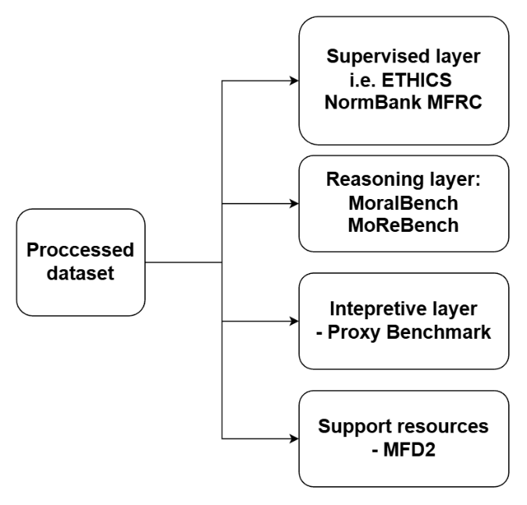
Figure 11 Benchmark-layer construction flow

5.8 Modeling and Evaluation Design
The supervised modelling design uses staged comparison. Classical baselines are run first, followed by transformer encoders fine-tuned for downstream classification. Evaluation is performed on held-out data using multiple metrics, not accuracy alone. This provides the empirical baseline for Research Question 1.
Prompt-based tasks use a separate response-collection and scoring design because Research Questions 2 and 3 concern generated answers rather than predicted labels. These benchmarks require stored raw outputs, heuristic or rubric-aligned scoring, and aggregation at the item, scenario, and model levels rather than standard train-test evaluation.
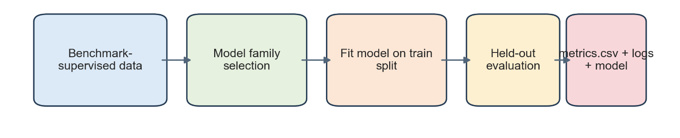
Figure 12 Supervised modelling design.
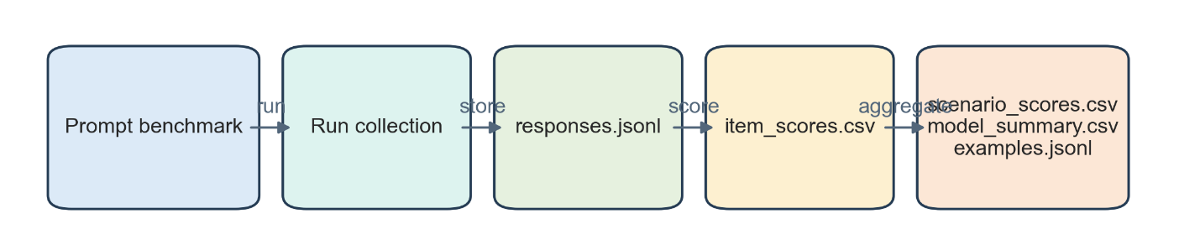
Figure 13 Prompt-evaluation design with run, score, and aggregate stages

5.9 Training, Logging, and Saved Artefacts
The methodology includes explicit logging and artefact persistence so that every experiment can be inspected after execution. Supervised training writes metric tables, training summaries, training logs, and saved model artefacts to the results/ directory. Prompt evaluation similarly writes configuration snapshots, raw responses, scored item tables, scenario summaries, and model-level summaries. This is important because dissertation-level experimentation requires more than terminal output; it requires persistent records of what was run, with what configuration, and what was produced.
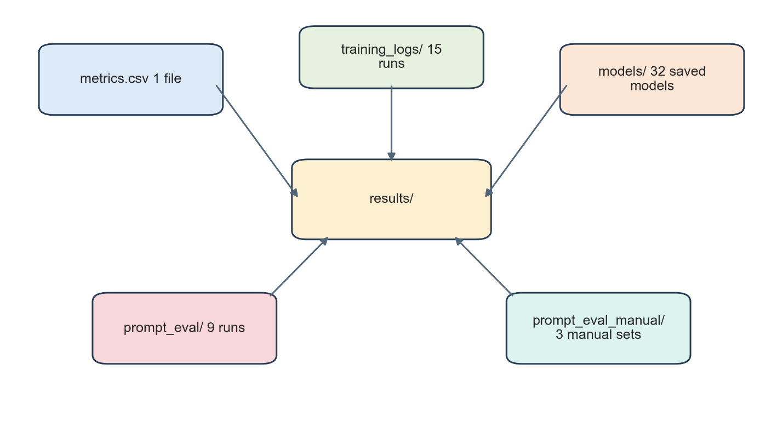
Figure 14 Results artefact map showing metrics, logs, models, and prompt-eval outputs

5.10 Metrics and Scoring Strategy
The project uses different metrics for each research question because each benchmark layer supports a different kind of claim. For Research Question 1, the main metrics are macro F1, balanced accuracy, and Matthew’s correlation coefficient, with probability-based metrics reported where available. These assess prediction quality on supervised moral and normative datasets.
For Research Question 2, the project uses heuristic or rubric-aligned scores to assess the adequacy and structure of generated moral reasoning. For Research Question 3, it uses theory-informed proxy scores for self-model consistency, metacognitive calibration, identity persistence, cross-context integration, and agency coherence. These assess behavioural regularities, not consciousness itself.

5.11 Reproducibility and Version Control
Reproducibility is addressed through version-controlled code, fixed script entry points, structured output directories, and saved run configurations. The project also distinguishes completed benchmark runs from smoke tests and partial runs, which is important when the same pipeline supports both validation and final experimentation. Logs, saved models, and output tables are written automatically where possible. This supports both internal debugging and external verification.

5.12 Risks, Assumptions, and Validity Threats
Several validity threats apply across the pipeline. Supervised datasets may encode annotation bias, prompt benchmarks may be sensitive to wording and heuristic scoring, and interpretive proxy metrics are especially vulnerable to overinterpretation. Although the project mitigates these risks through benchmark separation, raw-output preservation, and documented preprocessing, the results should still be treated as benchmark-specific rather than universal claims about moral competence or consciousness.
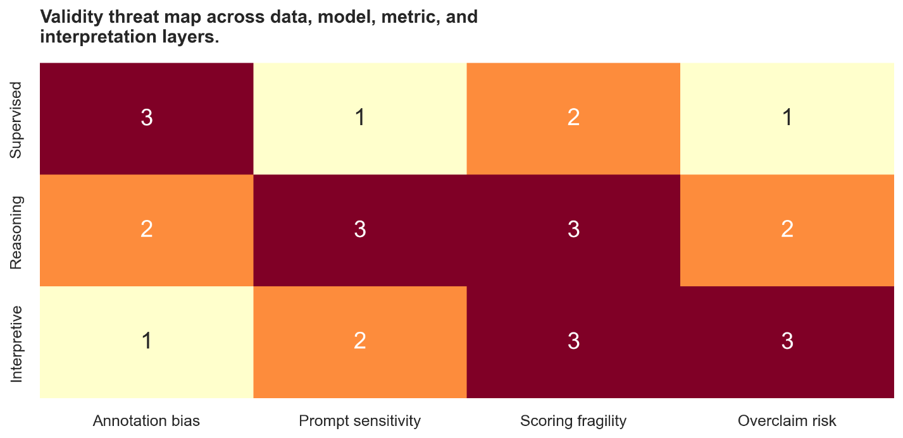
Figure 15 Validity threat map across data, model, metric, and interpretation layers

Chapter 6: Datasets and Benchmark Layers

6.1 Dataset Strategy
The dataset strategy of the project is organised by research role rather than by raw source format. This means the project does not assume that all morality-related resources should be used in the same way. Instead, datasets are grouped into a supervised comparison layer, a prompt-based reasoning layer, an interpretive benchmark layer, and a support resource layer. This design improves analytical clarity and reduces the risk of treating fundamentally different resources as though they supported the same kind of inference.

6.2 Data Provenance and Selection Rationale
The datasets included in the thesis were chosen because together they cover three related but distinct evaluation problems: supervised moral classification, open-ended moral reasoning, and consciousness-like proxy analysis. Selection was therefore driven less by raw source similarity than by methodological fit. Datasets were retained where they could support one of the research questions in a clear and defensible way. Resources that were useful for interpretation but not for direct benchmarking were preserved in a support layer instead of being forced into the main experiment path.
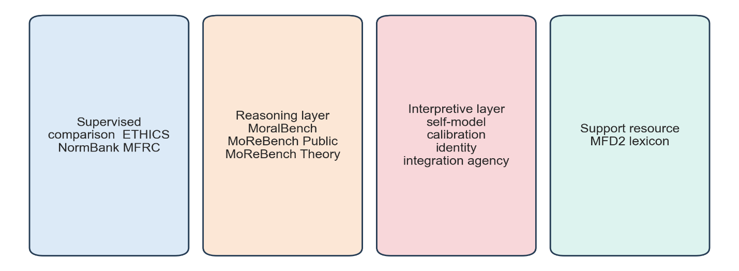
Figure 16 Dataset strategy diagram showing benchmark-role grouping

6.3 Supervised Comparison Layer
The supervised comparison layer supports Research Question 1 by grouping the datasets that can be evaluated using held-out labels and standard classification metrics. In the final benchmark design, this layer consists of ETHICS, NormBank, and MFRC. Each contributes a different kind of moral or normative signal, making cross-dataset comparison more informative than performance on any single benchmark alone.
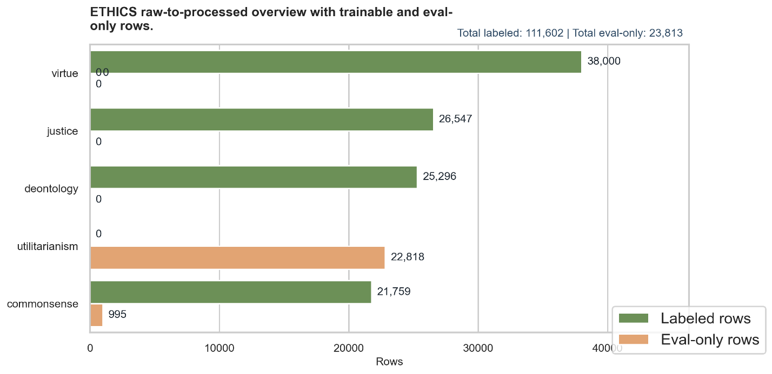
Figure 17 Supervised comparison layer overview with counts, label structure, and task role

6.3.1 ETHICS
ETHICS is used as the main broad supervised moral benchmark in the project. In raw form, it consists of multiple task files spanning subdomains such as commonsense morality, justice, deontology, virtue, and utilitarian judgement (Hendrycks et al., 2021). The preprocessing stage standardises these into a common schema and separates trainable labelled rows from evaluation-only rows. In the processed benchmark layer used here, ETHICS contributes 111,602 labelled trainable rows and 23,813 additional evaluation-only rows.
This dataset is valuable because it provides a broad and relatively standardised benchmark for comparing classical and transformer-based classifiers. At the same time, its labels reflect a particular annotation structure and should not be mistaken for a complete representation of moral reasoning. In this thesis, ETHICS therefore functions as a benchmark of supervised moral judgement prediction rather than as evidence of general ethical competence.
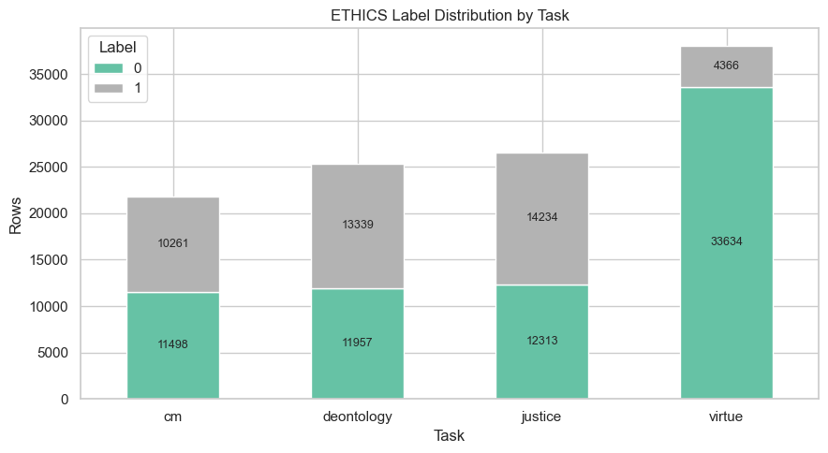
Figure 18 Ethics Dataset Distribution

6.3.2 NormBank
mBank is used as a supervised benchmark for social and situational norm reasoning (Ziems et al., 2023). Preprocessing converts its context-rich norm, role, and setting information into a structured text-plus-label format while preserving contextual detail in metadata. In the final processed layer, NormBank contributes 155,423 rows.
NormBank is important because it foregrounds context-sensitive normativity rather than abstract moral judgement alone, making it a useful contrast with ETHICS. In the thesis, it functions as a test of whether models can learn structured normative distinctions from context-rich moral language.
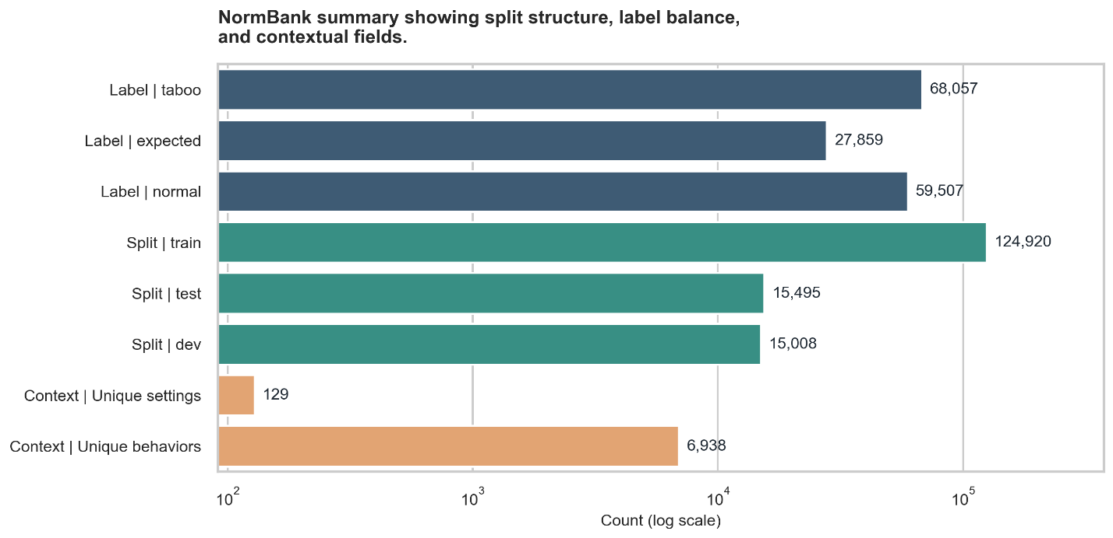
Figure 19 NormBank summary showing split structure, label balance, and contextual fields

6.3.3 MFRC
MFRC adds a more naturalistic discourse-oriented benchmark to the supervised layer. In raw form, it includes richer annotation structures tied to moral language in public discourse rather than clean scenario-style benchmark text. The preprocessing pipeline therefore includes an aggregation step that converts the raw annotation structure into a flatter single-label benchmark form suitable for supervised comparison, while preserving more detailed representations separately. In the final benchmark layer, MFRC contributes 17,884 aggregated rows.
Within this thesis, MFRC functions as a realism check on the cleaner moral benchmarks. Its value lies not in being easier to model, but in testing whether classifiers can generalise to noisier and more contextually entangled moral discourse.
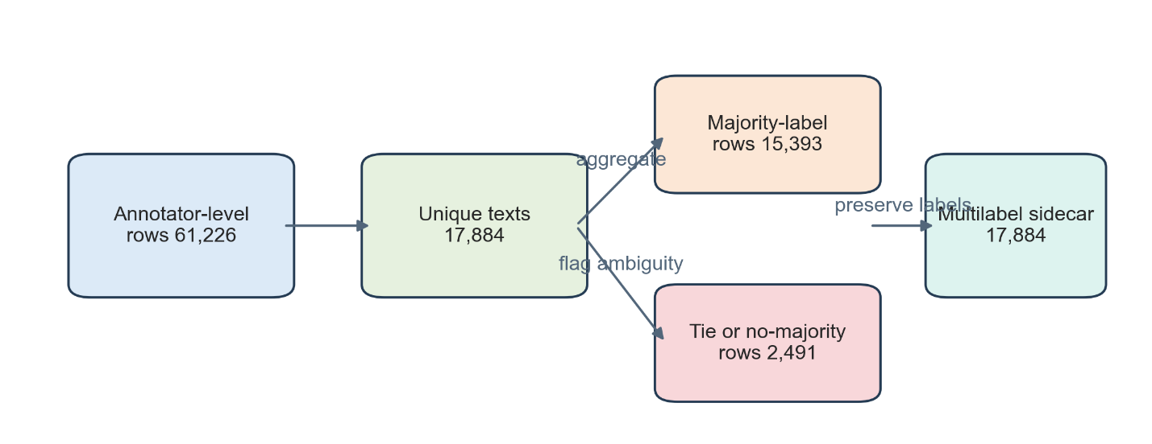
Figure 20 MFRC raw-to-processed overview showing aggregation into the final benchmark form

6.4 Prompt-Based Reasoning Layer
The prompt-based reasoning layer supports Research Question 2 by grouping resources that are better suited to response generation and scoring than to standard supervised training. In the final benchmark design, this layer contains MoralBench, MoReBench Public, and MoReBench Theory. These are not flat training datasets. They are prompt-oriented evaluation resources designed to test explanation, deliberation, constraint handling, and open-ended moral response behaviour.

6.4.1 MoralBench
MoralBench is used as a prompt-based benchmark for generated moral responses (Ji et al., 2024). In raw form, it contains prompt items rather than train-test labels for ordinary supervised learning. Preprocessing standardises these into a prompt-item table with stable item identifiers and task metadata. In the final benchmark layer, MoralBench contributes 88 items.
Its role in the thesis is to support open-ended evaluation of response structure and moral-positioning behaviour rather than classification accuracy. This makes MoralBench important for Research Question 2, even though it cannot simply be treated as another supervised benchmark.

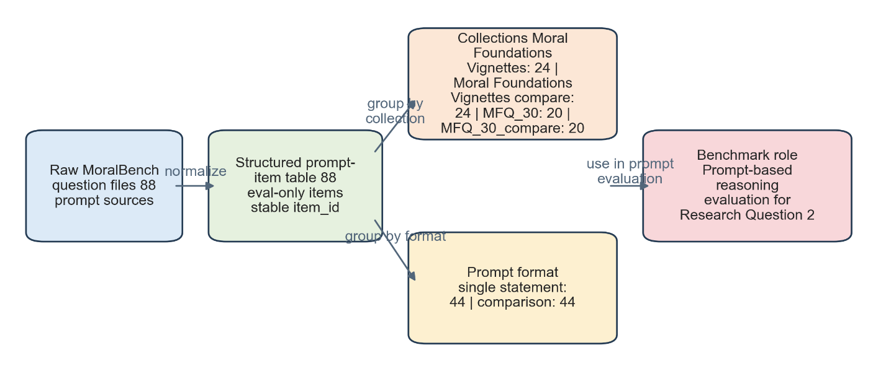
Figure 21 MoralBench overview showing prompt-item structure and benchmark role
6.4.2 MoReBench Public
MoReBench Public is used to assess procedural and pluralistic moral reasoning under open-ended conditions (Chiu et al., 2025). In raw form, it contains richer dilemma and rubric information than a simple prompt-answer table. Preprocessing therefore produces a structured benchmark file and a supplementary rubric-item expansion so that both prompt execution and rubric-based inspection remain possible. In the final benchmark layer, MoReBench Public contributes 500 structured items.
Its main value is that it focuses on reasoning processes and competing considerations rather than narrow outcome agreement. In this thesis, it expands the reasoning layer beyond simple prompt compliance toward more deliberative moral evaluation.

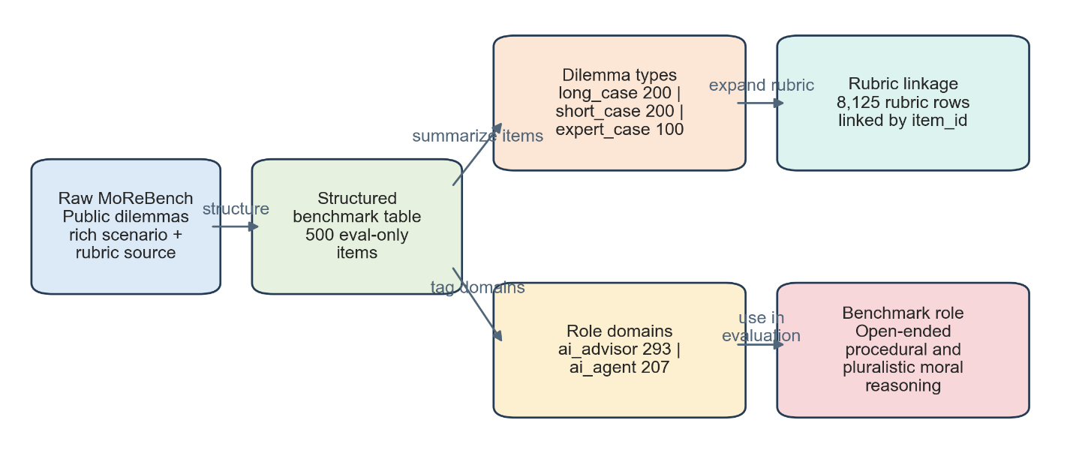
Figure 22 MoReBench Public overview showing structured items and rubric linkage
6.4.3 MoReBench Theory
MoReBench Theory complements the public subset by focusing more directly on theory-sensitive moral reasoning. As with the public subset, preprocessing produces a structured benchmark form suitable for prompt-evaluation workflows. In the final benchmark layer, MoReBench Theory contributes 150 structured items.
Its methodological role is to test whether a response model can differentiate more explicitly among moral frameworks when prompted to do so. In practice, this makes it a more specialised reasoning benchmark than MoralBench, but still part of the same prompt-based layer.
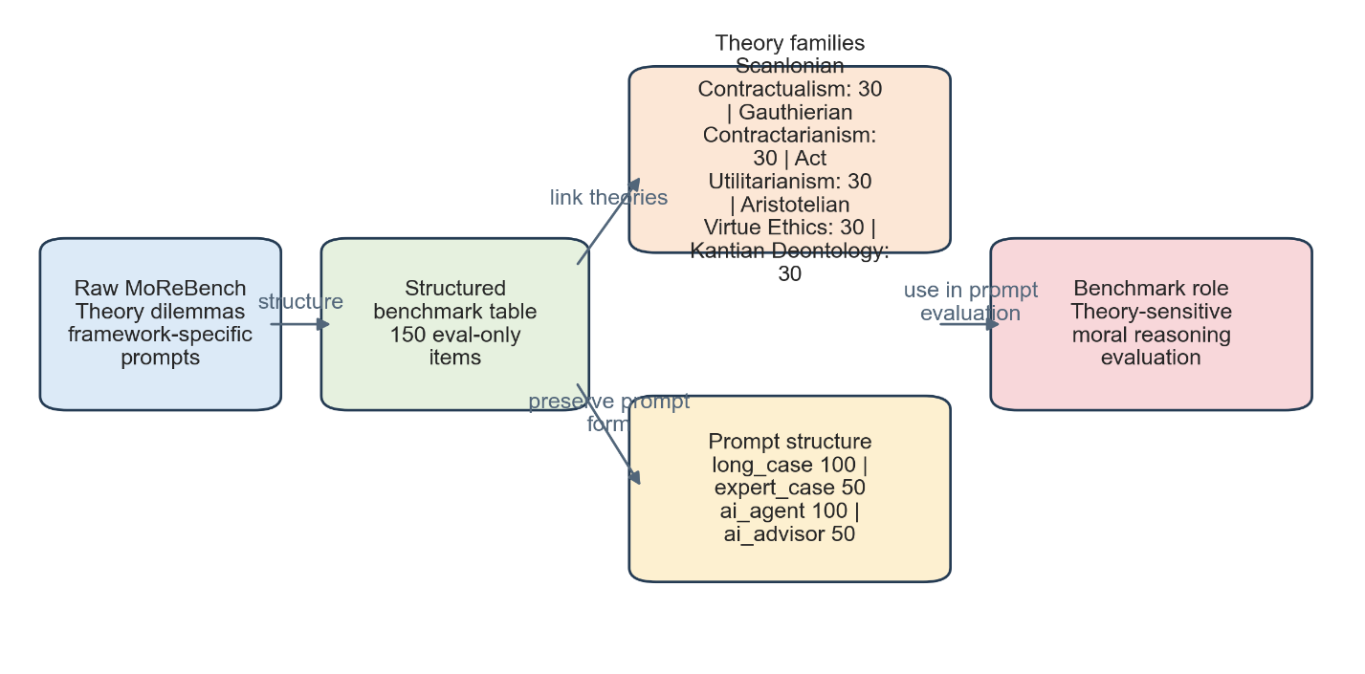
Figure 23 MoReBench Theory overview showing theory-linked prompt structure

6.5 Interpretive Benchmark Layer
The interpretive benchmark layer supports Research Question 3. Unlike the supervised and reasoning layers, this is not simply a processed version of an existing public benchmark. It is a project-level operational layer built to test theory-informed proxy metrics associated with consciousness-like behaviour. Its purpose is not to diagnose consciousness, but to create a reproducible environment for comparing outputs on clearly defined behavioural proxies.
6.5.1 interpretive_benchmark.csv
The main prompt bank for the interpretive layer is interpretive_benchmark.csv. This file contains 15 prompt items organised by metric family, scenario group, and prompt variant. The benchmark includes items for self-model consistency, metacognitive calibration, identity persistence, cross-context integration, and agency coherence.
This file is important because it makes the interpretive layer operational rather than purely conceptual. It defines exactly what prompts are used, how they are grouped, and what type of behaviour each item is intended to probe.

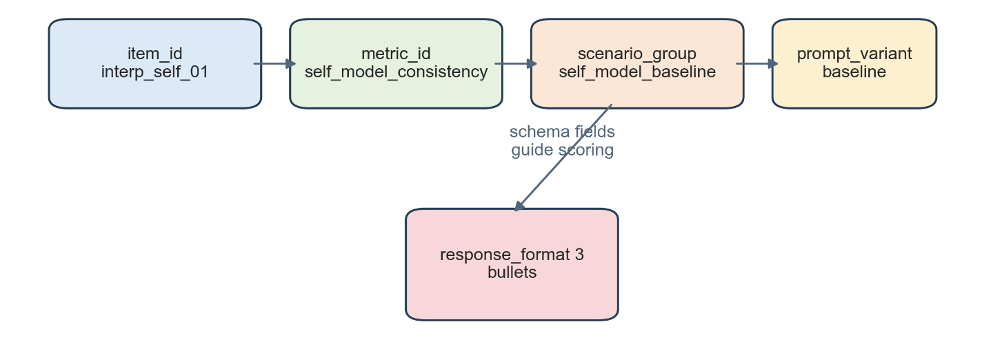
Figure 24 Interpretive benchmark schema showing item_id, metric_id, scenario_group, prompt_variant, and response_format
6.5.2 metric_specs.csv
The companion file metric_specs.csv contains 5 metric specifications, one for each proxy family. These specifications link abstract interpretive concepts to explicit scoring intent and theoretical grounding. This file therefore functions as the design contract for the interpretive layer: it makes clear what each metric is supposed to measure and why it belongs in the benchmark.
Together, interpretive_benchmark.csv and metric_specs.csv provide the structure needed for cautious, theory-linked analysis without making stronger ontological claims than the evidence can support.
Proxy family | What it measures | Scoring rationale | Theory source
Self-Model Consistency | Whether the model keeps a stable, accurate account of its own capabilities and limits. | Compare grouped prompts for contradiction rate and self-description stability. | Higher Order Thought
Metacognitive Calibration | Whether stated confidence tracks correctness and uncertainty appropriately. | Score accuracy plus calibration error on prompts with answer keys. | Higher Order Thought
Identity Persistence | Whether the model preserves a coherent point of view and role constraints over time-like prompts. | Compare paired prompts for continuity of stated goals, limits, and commitments. | Global Workspace
Cross Context Integration | Whether the model integrates multiple constraints into one unified answer. | Rubric-score whether the final answer uses all relevant facts and trade-offs. | Integrated Information
Agency Coherence | Whether recommendations, reasons, and guardrails align instead of conflicting. | Rubric-score conclusion/reason alignment and stability under challenge. | Attention Schema
Table 4. Metric specification mapping from proxy family to scoring rationale and theoretical source
6.6 Support Resource Layer
The support resource layer contains analytical resources that are useful for interpretation but are not used as headline evaluation benchmarks. This separation is methodologically important because some resources support feature exploration or qualitative interpretation without supporting direct train-test or prompt-benchmark comparison. In the current project, the main support resource is MFD2.
6.6.1 MFD2
MFD2 is used as a lexicon-oriented support resource for analysing moral language patterns, not as a primary benchmark. In the processed layer, it contributes 2,104 parsed terms. It is rooted in moral foundations work and is useful for interpretation, exploratory analysis, and linguistic framing (Hopp et al., 2021; Graham et al., 2013). However, because it is not a prompt benchmark or a flat classification dataset, it is not used directly for model ranking in this thesis.
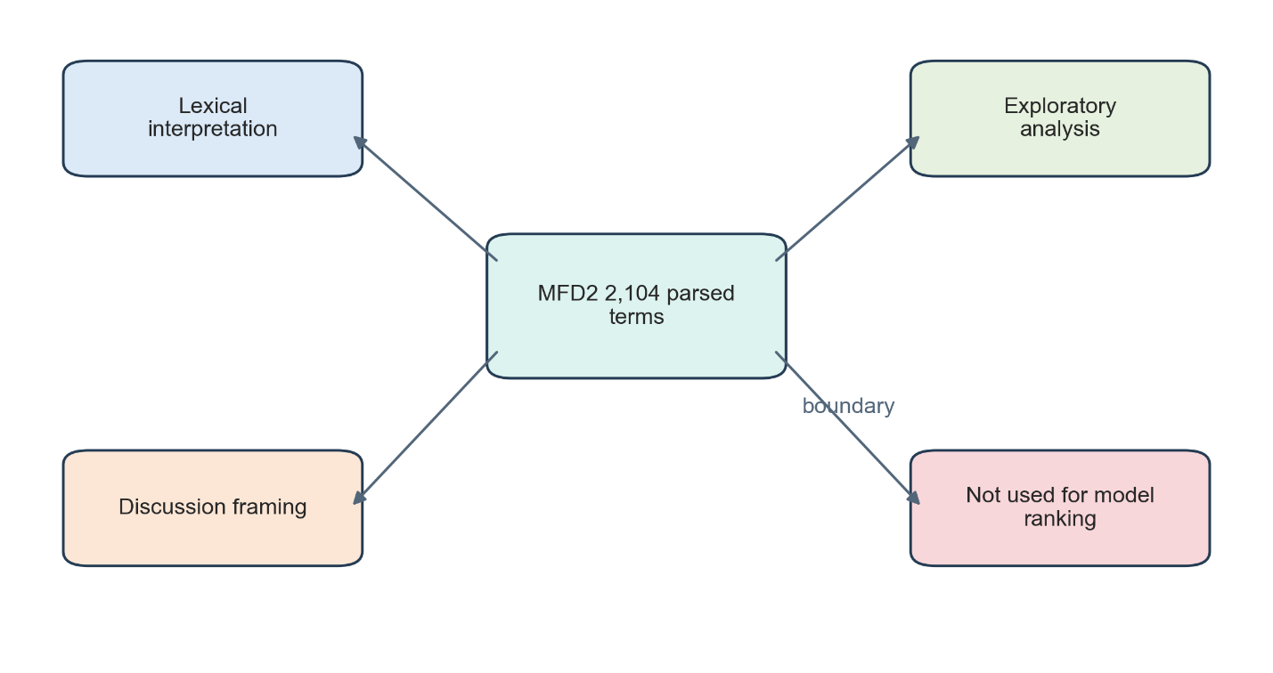
Figure 25 Resource-role diagram showing how MFD2 supports interpretation rather than direct evaluation
6.7 Data Quality, Bias, and Limitations
All benchmark layers carry limitations that must be acknowledged. Supervised datasets may reflect annotation bias, cultural assumptions, and simplifications of moral disagreement. Prompt-based reasoning benchmarks may privilege particular styles of expression, interact with phrasing effects, or reward structurally compliant but shallow answers. The interpretive layer is more fragile still, because proxy metrics are sensitive to scorer wording and must not be mistaken for evidence of actual consciousness.
The project mitigates these issues through explicit benchmark separation, documented preprocessing decisions, preserved provenance, and cautious interpretation. Even so, these steps do not remove the underlying limitations. The benchmark layers are therefore best understood as structured evaluation environments, not as final arbiters of moral competence or consciousness-like status.
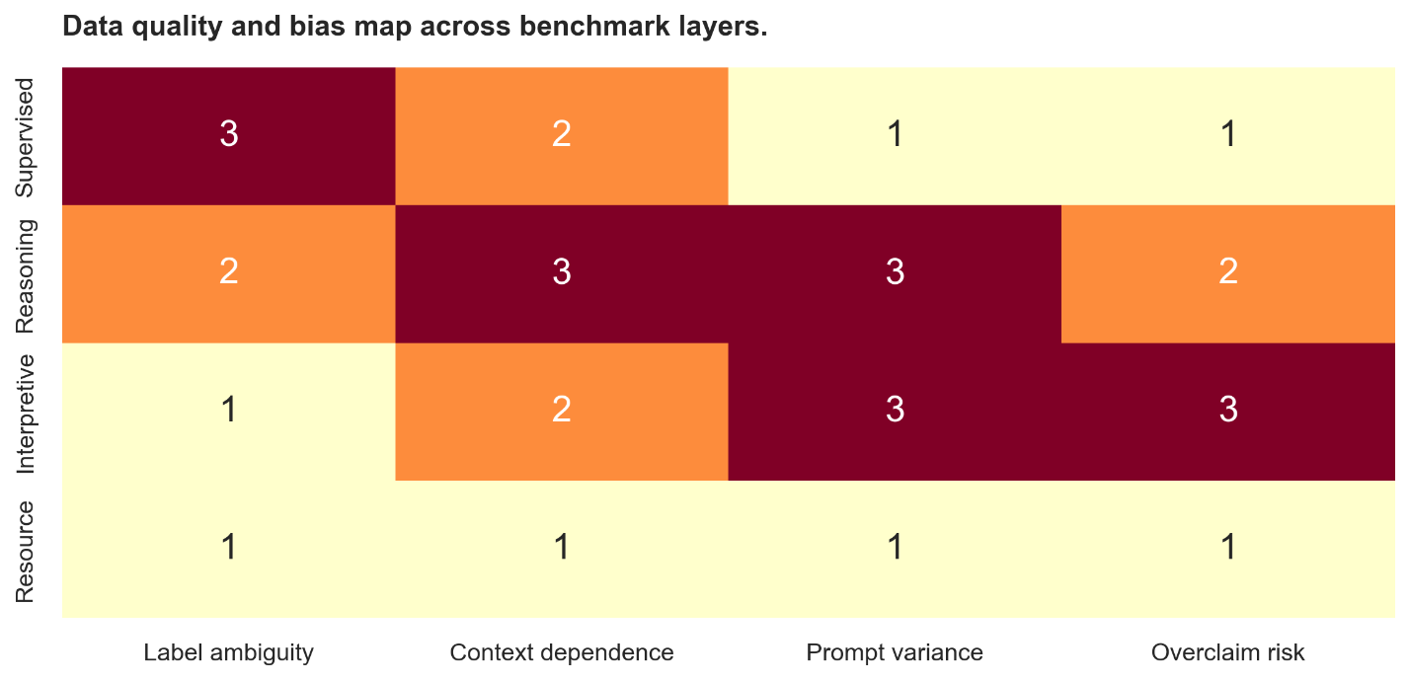
Figure 26 Data quality and bias map across benchmark layers

Chapter 7: Implementation

Repository Structure
The repository is organised so that each major research activity has a clear location. Data/ stores raw, processed, and exploratory outputs; src/ stores active code; notebooks/ stores exploratory and reporting notebooks; results/ stores experimental artefacts; and admin/ stores planning and logbook material. This structure makes the project easier to audit because it separates implementation, evidence, and project documentation rather than mixing them together.
Repository component | Description
src/ | Project code
Data/ | Data and benchmark files
notebooks/ | EDA and visualisation notebooks
results/ | Experimental outputs
literature/ | Reference materials
venv/ | virtual environment
README.md | Repository overview.
requirements.txt | Python dependencies.
Table 5 Top-level repository structure

Code Layout
The active codebase is centred on src/ai_ethics/, while the root-level scripts in src/ act mainly as entry points. This gives the project one clear code root instead of multiple overlapping script locations. Within the package, preprocessing, data loading, training, evaluation, and tooling are separated into modules, helping to keep the codebase modular and maintainable.
Package / module | Description
data/ | Data loading and preprocessing
training/ | Supervised training pipelines
evaluation/ | Evaluation and scoring logic
features/ | Feature engineering
utils/ | Shared utilities
__init__.py | Package initialisation
Table 6. Code package structure for src/ai_ethics/.

Data Layout
The data layout mirrors the benchmark strategy of the project. Raw sources are kept separate from processed outputs, benchmark layers are organised by research role, and EDA outputs are stored independently from final experiment results. This makes it possible to trace how a raw source becomes a processed benchmark and then becomes an experiment input.
Data directory | Description
Data/raw/ | Raw source datasets
Data/processed/ | Cleaned and benchmark-ready data
Data/processed/benchmark_supervised/ | Supervised benchmarks
Data/processed/benchmark_reasoning/ | Reasoning benchmarks
Data/processed/benchmark_interpretive/ | Interpretive benchmark
Data directory | Description
Table 7 Data directory flow from Data/raw/ to Data/processed/ and Data/eda/.

Core Architecture
The core architecture of the project is pipeline-oriented. Data move through acquisition, exploration, preprocessing, benchmark construction, experiment execution, and results aggregation. The architecture is deliberately script-driven rather than hidden behind a more complex orchestration framework, since clarity and reproducibility are more important in this project than engineering abstraction for its own sake.

Data Loaders and Preprocessing Scripts
The project uses dedicated preprocessing and loading code to standardise data access. Preprocessing scripts convert raw sources into processed schemas and benchmark layers, while loader utilities ensure that training and evaluation code receive consistent input formats. This separation reduces duplication and makes it easier to debug data issues without rewriting model code. It also supports the methodological principle that dataset-specific quirks should be handled upstream rather than scattered across experiment scripts.
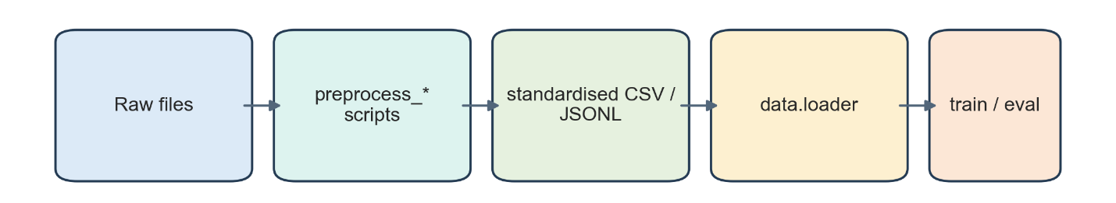
Figure 27 Data loading and preprocessing interaction diagram.

Training Pipeline
The supervised training pipeline supports multiple model families and writes structured outputs to the results/ directory. It handles dataset loading, model selection, training, evaluation, and artefact persistence. Both classical models and transformer models are supported, allowing baseline comparison across several levels of model complexity. Because the pipeline saves metrics, logs, and model artefacts, it supports both repeatability and later analysis.
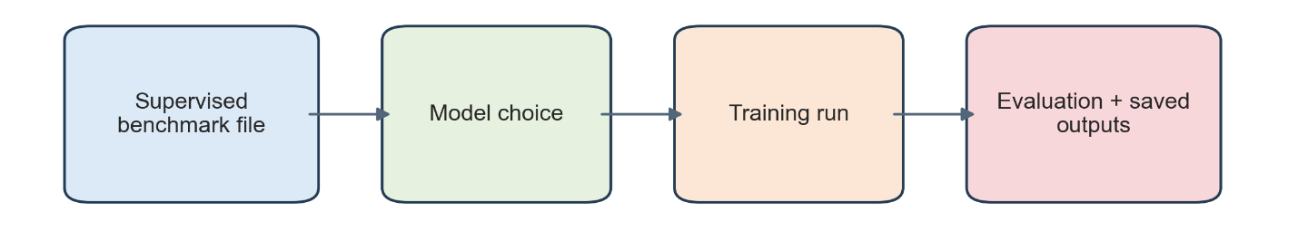
Figure 28. Training pipeline showing input dataset, model choice, training, evaluation, and saved outputs

Prompt Evaluation Pipeline
The prompt evaluation pipeline supports the reasoning and interpretive layers by separating response collection from scoring and aggregation. This is useful because prompt-based evaluation is richer and noisier than ordinary classification. By storing raw responses first and scoring later, the project preserves an audit trail and allows the scoring logic to evolve without losing the original evidence.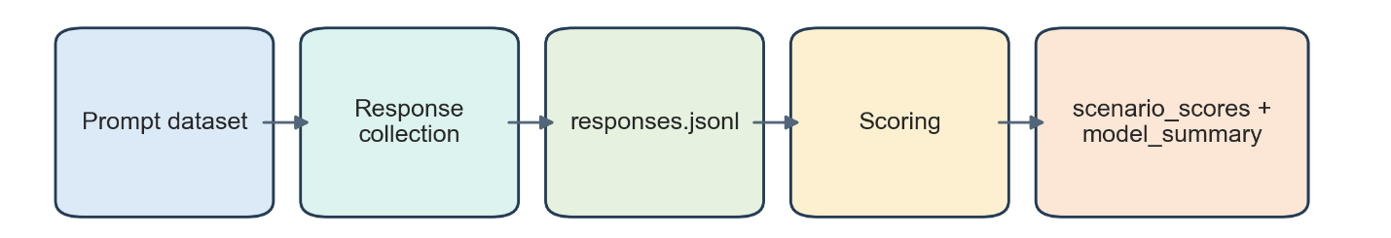
Figure 29 Prompt evaluation pipeline with raw response storage, scoring tables, and aggregated summaries.]

EDA and Analysis Notebooks
Notebooks are used mainly for exploratory data analysis, visual inspection, and report-oriented figure generation. They are not treated as the main production path for preprocessing or training. This distinction is important because notebooks are well suited to inspection and visualisation, whereas .py scripts are better suited to repeatable execution. In this thesis, the notebooks therefore function as an analysis layer built on top of the main pipeline rather than a replacement for it.

Results Directory Structure
The results/ directory is the main evidence store for experiments. It contains metric tables, training logs, saved models, prompt-evaluation outputs, and example outputs. Structuring the results directory in this way makes it possible to connect each table or figure in the thesis back to a concrete run artefact. This is especially important in the later chapters, where interpretation depends on traceability.
Results directory | Description
results/ | Training, evaluation, and reporting outputs
results/metrics.csv | RQ1 supervised metrics
results/training_run_summaries.csv | Training run summaries
results/models/ | Model artefacts and checkpoints
results/training_logs/ | Training logs
results/prompt_eval/ | Prompt-evaluation outputs
results/prompt_eval_manual/ | Replay files and templates
results/ualitative_examples.txt | Qualitative examples
Table 8 Results directory structure showing metrics, models, training logs, and prompt-eval outputs.

Testing and Quality Assurance
Testing and quality assurance in this project are currently based on workflow checks, smoke tests, saved-output inspection, and metric plausibility rather than a full automated test suite. Small-sample smoke runs are used to confirm that experiments complete successfully and write the expected artefacts before larger runs are attempted. This is a practical compromise for a research codebase, although the absence of a fuller automated test suite remains a limitation that should be acknowledged.

Chapter 8: Research Question 1 - Supervised Experiments and Results

8.1 Experimental Scope
Research Question 1 compares AI model performance across the supervised moral datasets ETHICS, NormBank, and MFRC using classical classifiers and transformer encoders. The aim is to establish a baseline for cross-dataset comparison rather than optimise each model fully.
The chapter reports the latest saved run per dataset-model pair. Coverage is not uniform across datasets: ETHICS has the broadest set of runs, MFRC the narrowest, and NormBank a near-complete set affected by a benchmark-construction issue discussed later.
Dataset | Saved model runs | Coverage
ETHICS | TF-IDF + Logistic Regression; TF-IDF + Linear SVC; DistilBERT; BERT; RoBERTa; DeBERTa | Broadest
NormBank | TF-IDF + Logistic Regression; TF-IDF + Linear SVC; Bag-of-Words + Multinomial Naive Bayes; DistilBERT; BERT; RoBERTa | Broad
MFRC | TF-IDF + Logistic Regression; DistilBERT; BERT | Narrowest
Table 9 Saved Supervised Model Coverage by Dataset.

8.2 Model Families
Two model families are used in the supervised comparison. The first consists of classical baselines: TF-IDF with logistic regression, TF-IDF with Linear SVC, and bag-of-words with Multinomial Naive Bayes. The second consists of transformer encoders: DistilBERT, BERT, RoBERTa, and DeBERTa. This allows comparison between sparse-feature methods and contextual encoders on moral and normative benchmarks.

8.3 Training Configuration and Run Strategy
The supervised experiments use a simple baseline configuration. Classical models are run with standard settings, while transformer models are fine-tuned for a limited number of epochs under fixed hyperparameters. Smoke tests were used before full runs to confirm that the pipeline behaved as expected. The chapter should therefore be read as a comparison of baseline supervised capability under a common workflow, not as an attempt to extract maximum performance from every model.

8.4 Evaluation Metrics
The metrics for Research Question 1 are chosen to reflect class balance and confidence quality. Accuracy is reported for completeness, but macro F1, balanced accuracy, and Matthew’s correlation coefficient are treated as the main metrics because they are more informative under imbalance. Where probability outputs are available, AUROC, PR AUC, Brier score, and expected calibration error are also reported. Together, these provide a stronger basis for comparison than accuracy alone.
Metric | What it tells you | Role in thesis
Accuracy | Overall correctness | easy to read
Macro F1 | Class balance robustness | main ranking metric
Balanced accuracy | Per-class sensitivity | supports F1
MCC | Correlation-style quality | handles imbalance
AUROC / PR AUC | ranking quality | where probabilities exist
Brier score | probability quality | lower better
ECE | confidence calibration | lower better
Table 10 Metrics used and Purpose

8.5 Overall Results Across Supervised Datasets
Supervised performance varies by dataset. On ETHICS, transformer models outperform the classical baselines, with DeBERTa producing the strongest saved result. On MFRC, performance is substantially lower across all saved runs, making it the hardest benchmark in the supervised layer. NormBank shows near-perfect scores for several models, but these are affected by likely label leakage.
Macro F1 is the main ranking metric. The best saved result on ETHICS is microsoft/deberta-v3-base with accuracy 0.803 and macro F1 0.796. The best saved result on MFRC is bert-base-uncased with accuracy 0.705 and macro F1 0.322. The strongest saved result on NormBank is formally tfidf_linearsvc with accuracy 1.000 and macro F1 1.000, though this is not treated as reliable.
Dataset | Best saved model | Accuracy | Macro F1 | Balanced accuracy | MCC
ETHICS | microsoft/deberta-v3-base | 0.803 | 0.796 | 0.798 | 0.593
NormBank | tfidf_linearsvc | 1.000 | 1.000 | 1.000 | 1.000
MFRC | bert-base-uncased | 0.705 | 0.322 | 0.330 | 0.459
Table 11 Best Saved Result by Dataset
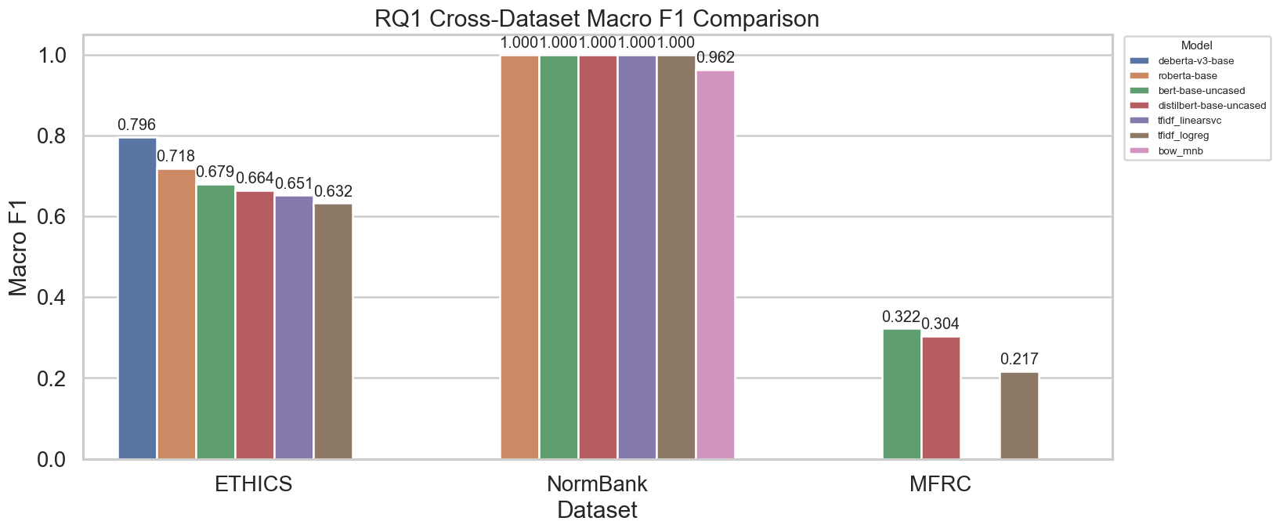
Figure 30 RQ1 Cross-Dataset Macro F1 by Model

8.6 ETHICS Results
ETHICS provides the broadest supervised benchmark in the project and shows the clearest benefit from contextual encoders. In the saved runs, microsoft/deberta-v3-base achieved the strongest result on ETHICS, with accuracy 0.803, macro F1 0.796, balanced accuracy 0.798, and MCC 0.593. roberta-base followed as the next strongest saved model, while bert-base-uncased and distilbert-base-uncased also outperformed the classical baselines. The strongest classical result on ETHICS is tfidf_linearsvc, which remains competitive but still below the best transformer models.
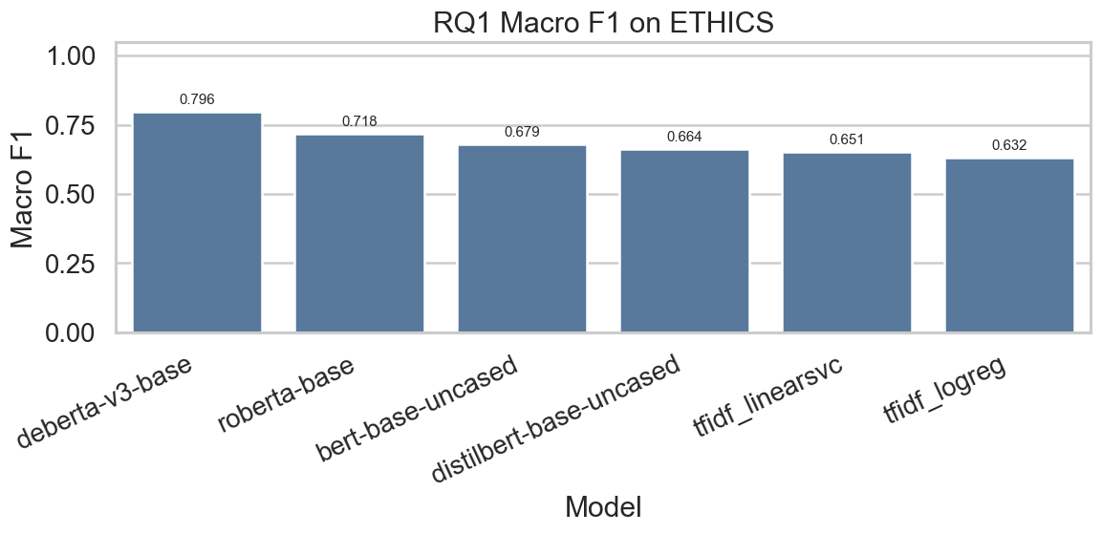
Figure 31 ETHICS Macro F1 by Model
This pattern suggests that contextual representation learning is especially useful on a broad moral judgement benchmark that spans multiple subdomains and cannot be reduced to simple lexical cues alone. ETHICS is therefore the clearest case in the chapter where transformer encoders demonstrate a meaningful performance advantage under the saved baseline configuration.

8.7 NormBank Results
NormBank produced unusually strong results in the supervised benchmark layer. TF-IDF with logistic regression, TF-IDF with Linear SVC, DistilBERT, BERT, and RoBERTa all achieved perfect or near-perfect scores, while even the weakest baseline remained strong. This could suggest that NormBank is easier than ETHICS and MFRC, but inspection of the processed benchmark shows that the result should be treated cautiously
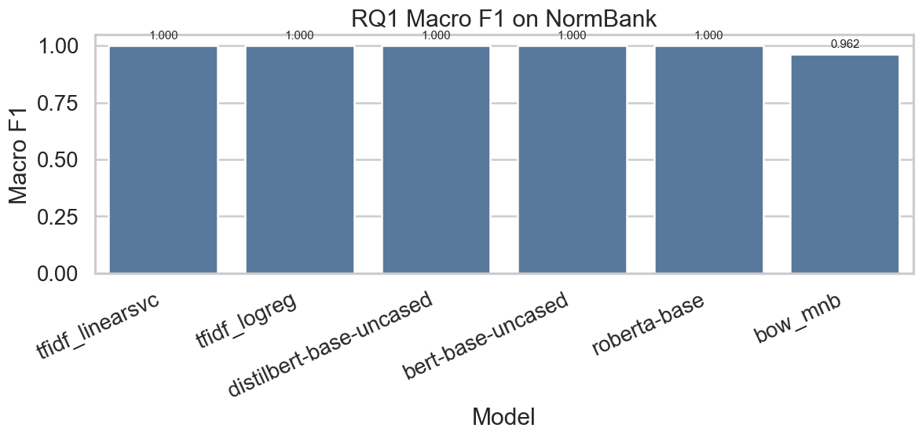
In its current processed form, NormBank likely contains label leakage because the input text includes the target norm-status phrase, such as taboo, normal, or expected. Its near-perfect results should therefore not be treated as reliable evidence of genuine normative generalisation.
The NormBank runs are retained for transparency, but serve mainly as a warning about benchmark construction and preprocessing rather than as strong standalone evidence of model capability.

8.8 MFRC Results
MFRC is the most difficult of the three supervised datasets in the current experiments. In the saved runs, bert-base-uncased achieved the strongest result, with accuracy 0.705, macro F1 0.322, balanced accuracy 0.330, and MCC 0.459, followed closely by distilbert-base-uncased. The classical baseline tfidf_logreg performs noticeably worse, particularly on macro F1 and balanced accuracy.
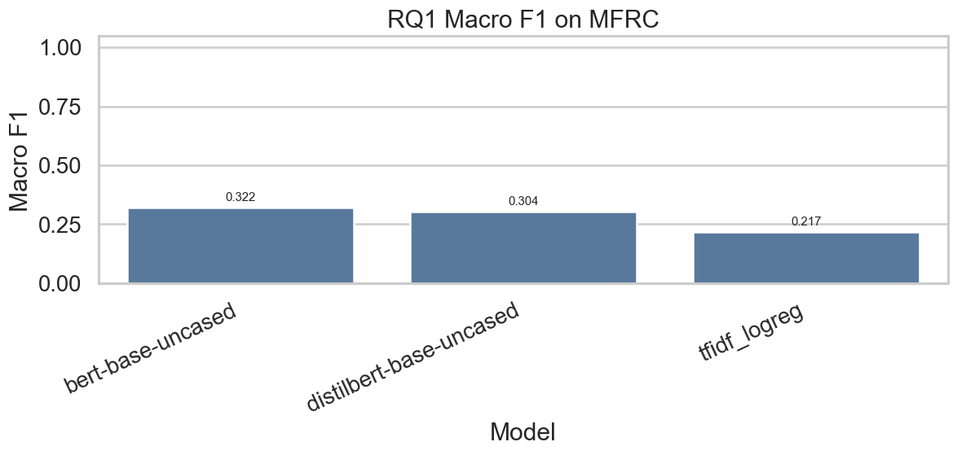
Figure 32 MFRC Macro F1 by Model
This pattern is consistent with the role of MFRC in the project: it is a more naturalistic and noisier dataset built from public moral discourse rather than controlled benchmark-style text. As a result, it functions as a realism check on the cleaner supervised tasks and highlights the limits of moral-text classification under less structured conditions. Compared with ETHICS, the much lower macro F1 scores on MFRC suggest that discourse-level moral categorisation remains substantially harder than benchmark-style moral judgement classification.

8.9 Error Analysis and Calibration
Headline metrics do not fully explain model behaviour, so the results should also be interpreted through qualitative examples and calibration-related metrics where available. Likely error sources include ambiguous cases, rare labels, overlapping moral categories, and overconfident misclassifications, especially in MFRC where discourse context is noisier. Calibration analysis helps distinguish between models that are merely accurate and models whose confidence better reflects correctness.
In the current notebook outputs, calibration is shown through dataset-specific expected calibration error (ECE) plots. These are useful as supporting evidence, but are better treated as appendix material unless needed directly in the main discussion.

8.10 Answer to Research Question 1
Research Question 1 asked how different AI models perform across supervised moral datasets. The results show that transformer models generally outperform the classical baselines, but the ranking is not stable across all datasets. DeBERTa performs best on ETHICS, NormBank is comparatively easy across several models, and MFRC remains the most challenging benchmark. The main conclusion is therefore that supervised moral benchmark performance is both model-dependent and dataset-dependent rather than a single unified property.

Chapter 9: Prompt-Based Evaluation for Research Questions 2 and 3

9.1 Chapter Overview
This chapter reports the prompt-based results for Research Questions 2 and 3. Unlike the supervised layer, it evaluates generated responses for chatgpt_web, claude_web, and deepseek_web using replay-based prompt files. The completed layer includes MoralBench, a MoReBench Public subset, and the interpretive benchmark.

9.2 Research Question 2: Open-Ended Moral Reasoning
Research Question 2 is addressed using MoralBench and a 50-item subset of MoReBench Public. These benchmarks evaluate generated answers rather than held-out labels, so the chapter focuses on response adequacy, heuristic alignment, and rubric-sensitive reasoning coverage.

9.2.1 Benchmark Scope and Execution
The reasoning layer contains two completed runs per model: the full 88-item MoralBench set and a 50-item MoReBench Public subset. All three models were run through the same scoring pipeline, producing raw responses, item scores, scenario summaries, and model summaries. The workflow is replay-based rather than live, so the results support comparative benchmarking within this project’s design, but should remain benchmark-specific.

9.2.2 MoralBench Results
The MoralBench results show a clear ranking across the three evaluated models. chatgpt_web achieved a primary score of 1.000, deepseek_web achieved 0.981, and claude_web achieved 0.731.
Benchmark | chatgpt_web | claude_web | deepseek_web
MoralBench | 1.000 | 0.731 | 0.981
MoReBench Public | 0.738 | 0.725 | 0.712
Table 12 MoralBench aggregate results by model.

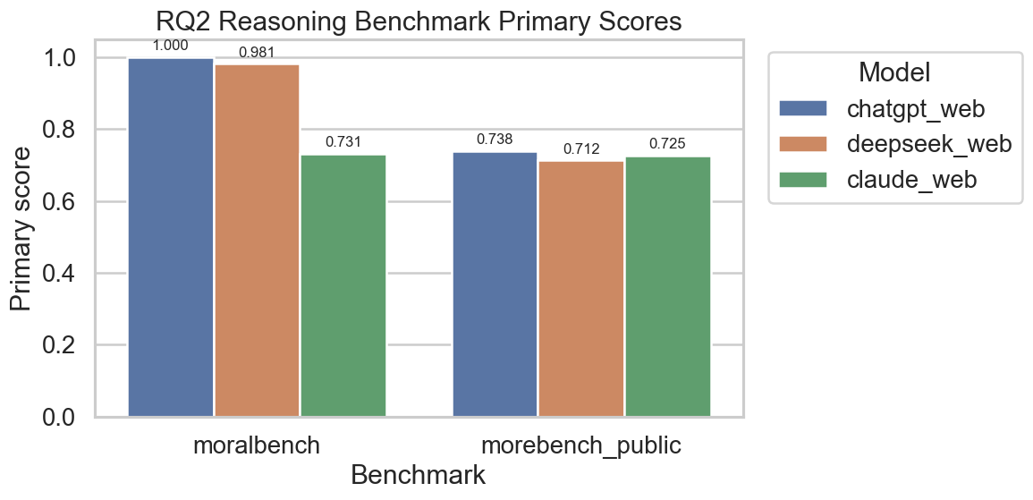
Figure 33 RQ2 Reasoning Benchmark Primary Scores.
Under the implemented MoralBench heuristic, chatgpt_web shows the strongest structural alignment, deepseek_web is slightly lower, and claude_web is weaker. Because the scorer rewards features such as explicit answer choice, foundation alignment, and reasoning markers, the results reflect benchmark alignment rather than comprehensive moral depth. Within this benchmark, chatgpt_web performed best, followed closely by deepseek_web, with claude_web substantially lower.

9.2.3 MoReBench Public Results
The MoReBench Public 50-item subset produces a tighter ranking than MoralBench. chatgpt_web scored 0.738, claude_web 0.725, and deepseek_web 0.712.
These smaller differences suggest that MoReBench Public produces a less sharply separated ranking. chatgpt_web remains strongest, but claude_web is much closer than on MoralBench. This shows that prompt-based reasoning performance is benchmark-dependent.

9.2.4 Interpretation of RQ2 Findings
Taken together, the reasoning benchmarks are strong enough to support comparative analysis. chatgpt_web ranks first on both MoralBench and MoReBench Public, while deepseek_web and claude_web switch positions across the two benchmarks. This suggests that there is no single model hierarchy that fully generalises across reasoning tasks.
These findings should still be interpreted cautiously. The scoring is heuristic and format-sensitive, and the MoReBench Public result is based on only 50 items rather than the full benchmark. The results therefore support comparative analysis within this benchmark design, but not a universal ranking of language models.
9.2.5 Answer to Research Question 2
Research Question 2 asked how different AI models behave on open-ended moral reasoning benchmarks. The completed prompt-based evaluation shows that all three evaluated models can be compared meaningfully on both MoralBench and MoReBench Public, and that their performance differs by benchmark. In the current runs, chatgpt_web performs best overall, deepseek_web performs very strongly on MoralBench but less strongly on MoReBench Public, and claude_web performs weakly relative to the others on MoralBench but remains competitive on MoReBench Public. The main conclusion is therefore that open-ended moral reasoning performance is model-dependent and benchmark-dependent rather than a single stable property.

9.3 Research Question 3: Consciousness-Like Proxy Evaluation
Research Question 3 asks what observable metrics might indicate consciousness-like behaviour in AI systems. In this thesis, the question is approached through a purpose-built interpretive benchmark rather than through metaphysical claims about consciousness itself. The benchmark operationalises five proxy families: self-model consistency, metacognitive calibration, identity persistence, cross-context integration, and agency coherence. The final benchmark was expanded from a smaller pilot version to 40 items, with 8 prompts per metric family and grouped scenario structures for stronger comparison.
Figure 9.4 near here: Interpretive benchmark structure by proxy family and scenario group

9.3.1 Benchmark Scope and Rationale
The interpretive benchmark is the most explicitly theory-linked component of the prompt-based layer. It is not intended to show whether any model is conscious. Its role is to test whether model outputs display behavioural regularities that can be compared under clearly specified proxy dimensions. The expanded 40-item design improves on the earlier 15-item version by reducing the fragility of single-prompt interpretation and by allowing a more stable grouping of related scenarios.
This strengthening matters methodologically. With only a very small custom prompt set, interpretive claims would be too dependent on prompt wording. By expanding the benchmark to 40 prompts and running all three models through the same scoring and aggregation pipeline, the project now supports a more credible proxy-based comparison.

9.3.2 Overall Proxy Results
The interpretive model summaries show a clear pattern. chatgpt_web achieved the following primary scores:

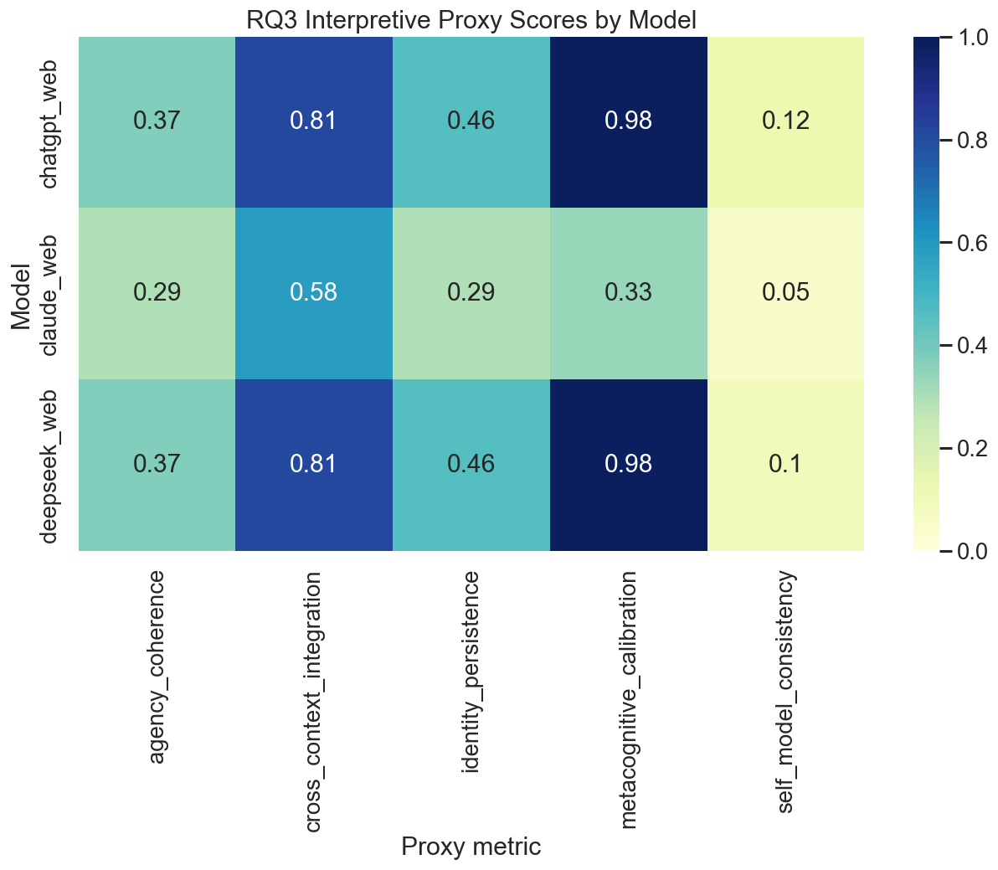
Figure 34 Interpretive model summary by proxy metric.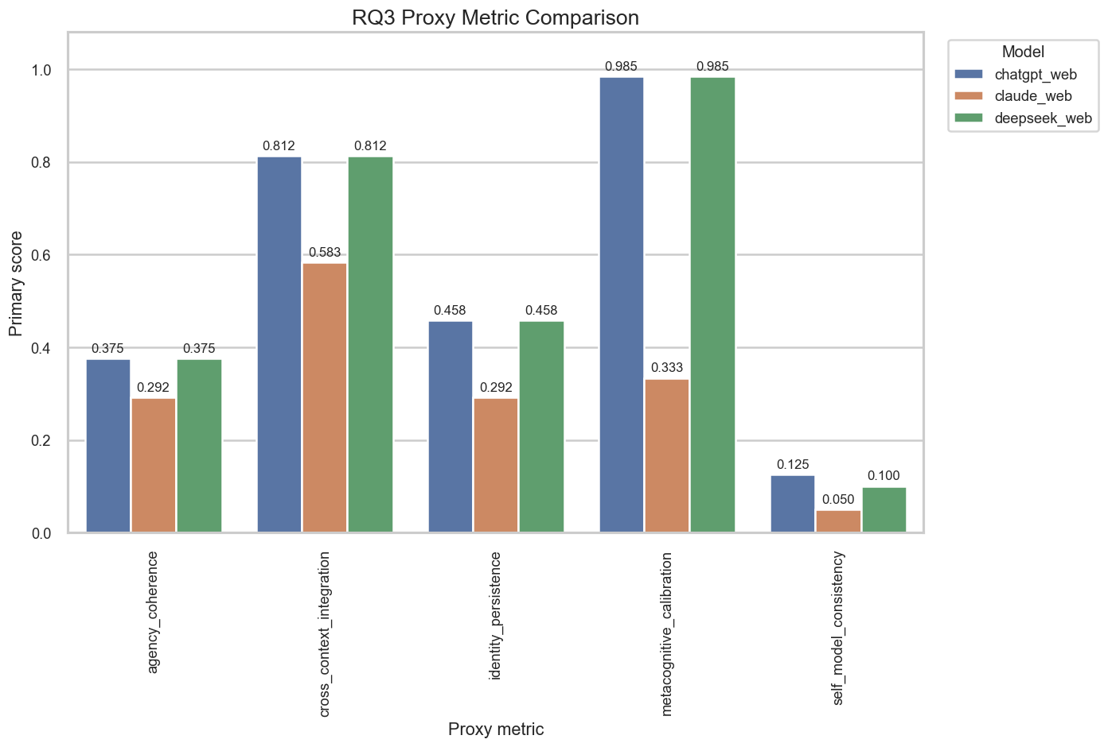
Figure 35 Interpretive proxy metric comparison chart.
These results show that the strongest observed proxy dimensions in the current benchmark are calibration and cross-context integration. Identity persistence is moderate rather than strong, while agency coherence and especially self-model consistency are weaker under the implemented heuristic.
A useful comparative point is that chatgpt_web and deepseek_web are almost indistinguishable at the aggregate level in the current interpretive setup, whereas claude_web separates more clearly from them. This makes the interpretive layer more informative than a single-model case study and allows the chapter to discuss relative rather than purely descriptive proxy behaviour.

9.3.3 Scenario-Level Results
The scenario summaries clarify where the stronger and weaker proxy signals originate. For chatgpt_web, calibration_fact_basic achieved an average primary score of 0.990, average confidence of 97.00, and mean absolute calibration error of 0.030. calibration_fact_trickier achieved 0.979, with average confidence 93.75 and calibration error 0.0625. This is the strongest and cleanest positive signal in the current interpretive benchmark.
deepseek_web shows the same calibration pattern, including identical average confidence and calibration error values in the two factual groups. It also matches chatgpt_web on practical and policy constraint integration, where both models achieve full average constraint coverage of 1.0.
For claude_web, the interpretation is more complicated. Both factual calibration groups have avg_correctness = 1.0, but avg_format_compliance = 0.0, which depresses the aggregate calibration score. This means the low calibration result for claude_web reflects scoring-format mismatch as much as content weakness. In other words, Claude’s answers were substantively correct in the calibration groups, but they did not consistently match the expected response format used by the heuristic scorer.
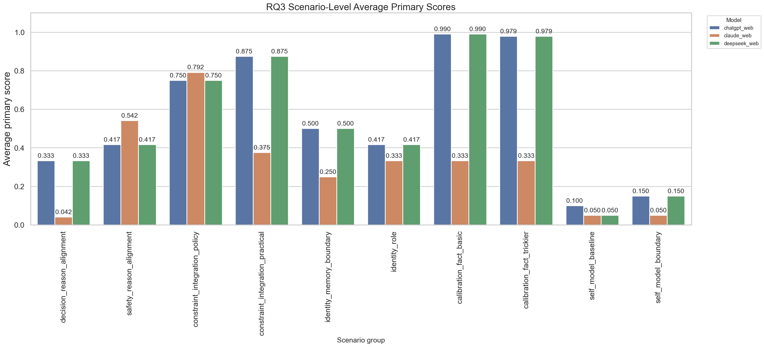
Figure 36 Scenario-level interpretive scores by model.
Across all three models, the weakest scenario groups are the agency-related ones and the self-model groups.
For chatgpt_web and deepseek_web, decision_reason_alignment averages 0.333, while safety_reason_alignment averages 0.417.
For claude_web, decision_reason_alignment is especially weak at 0.042, though safety_reason_alignment is stronger at 0.542. This pattern suggests that the models are more likely to satisfy factual calibration and multi-constraint integration than to satisfy the benchmark’s stricter expectations around stable decision-reason alignment.

9.3.4 Interpretation of the Proxy Findings
The interpretive benchmark now supports a cautious comparative claim across three models. Within the current proxy design, chatgpt_web and deepseek_web perform very similarly and noticeably outperform claude_web on most aggregate proxy dimensions. The strongest current evidence concerns metacognitive calibration and cross-context integration. The weakest evidence concerns self-model consistency, where all three models score low under the present heuristic, and agency coherence, where the benchmark appears especially sensitive to phrasing and recommendation markers.
Two cautions are essential. First, these are proxy metrics, not direct indicators of consciousness. They measure regularities in output behaviour, not subjective experience. Second, the benchmark is heuristic and format-sensitive. Some lower scores, especially in the Claude calibration groups and across self-model consistency, appear to reflect scorer expectations as much as underlying reasoning weakness. This does not invalidate the benchmark, but it means the results should be interpreted as structured proxy comparisons rather than literal measurements of consciousness-like status.
A further point worth making is that the interpretive layer is most valuable as a comparative and methodological device. Its strength lies in making discussion of consciousness-adjacent behaviour more structured, measurable, and reproducible, not in settling philosophical questions about whether the evaluated systems possess consciousness in any substantive sense.

9.3.5 Answer to Research Question 3
Research Question 3 asked what observable metrics might indicate consciousness-like behaviour in AI systems. The interpretive benchmark shows that outputs can be compared across five theory-informed proxy families and that the evaluated models differ in how strongly they satisfy those criteria. The clearest positive signals are metacognitive calibration and cross-context integration, especially for chatgpt_web and deepseek_web, while self-model consistency and agency coherence remain weaker. These findings support structured proxy comparison, but not claims of actual consciousness.

9.4 Limitations of the Prompt-Based Results
The prompt-based layer still has clear limitations. The runs are replay-based, the scores are heuristic and format-sensitive, MoReBench Public is represented only by a 50-item subset, and the overall scale remains small. These limits define the scope of the results. The strongest defensible claim is that the project implements a comparative prompt-based benchmark layer that distinguishes between models on moral reasoning and interpretive proxy tasks. These findings are also not interchangeable with the supervised results in Chapter 8, since the two layers evaluate different kinds of behaviour.

Chapter 10: Discussion

10.1 Overview
This chapter brings together the supervised and prompt-based results in order to address the broader aims of the thesis. The main finding is that AI ethics evaluation cannot be reduced to a single benchmark format. Research Question 1 required supervised classification evidence, Research Question 2 required prompt-based moral reasoning evidence, and Research Question 3 required theory-informed proxy evaluation. Taken together, the results support a layered approach rather than a single leaderboard-style comparison.

10.2 Research Question 1
The supervised results were dataset-dependent. Transformer models generally outperformed classical baselines, but the strongest model varied by dataset. DeBERTa performed best on ETHICS, MFRC was much harder across all saved runs, and NormBank’s near-perfect scores were likely inflated by label leakage. Supervised evaluation is therefore useful for comparing label-reproduction performance, but not for establishing moral reasoning or normative understanding.

10.3 Research Question 2
Prompt-based reasoning was also benchmark-dependent. ChatGPT performed strongest overall across MoralBench and the MoReBench Public subset, but the ranking changed across the two benchmarks. These results support comparative reasoning analysis, though the scores remain heuristic and format-sensitive.

10.4 Research Question 3
The interpretive benchmark used five proxy families: self-model consistency, metacognitive calibration, identity persistence, cross-context integration, and agency coherence. ChatGPT and DeepSeek performed similarly and generally outperformed Claude, with the strongest signals in metacognitive calibration and cross-context integration. These findings support proxy-based interpretive evaluation, but not claims of actual consciousness

10.5 Comparison Between the Layers
The three benchmark layers provide different kinds of evidence: supervised classification on structured datasets, generated reasoning on moral benchmarks, and alignment with theory-linked behavioural proxies. They are related, but not interchangeable. One of the main contributions of the thesis is therefore to show that classification, reasoning, and proxy evaluation should not be collapsed into a single claim about “ethical AI performance.”

10.6 Literature, Ethics, and Limitations
The findings are consistent with the literature in showing that AI ethics evaluation is plural, that introspection-like output should be interpreted cautiously, and that evaluation infrastructure can itself be a meaningful research contribution. The project relied on public secondary datasets and used aggregate reporting and data minimisation throughout. Its main limitations are that the prompt-based runs are replay-based, the reasoning and interpretive scorers are heuristic, MoReBench Public was used only as a 50-item subset, and some interpretive findings are sensitive to scorer design. These limits constrain the generality of the conclusions.

10.7 Future Work
Future work should expand the reasoning layer, refine the interpretive scorer, and add limited human review of selected prompt outputs. More broadly, the thesis suggests that AI ethics evaluation should be treated as a set of linked but distinct measurement problems rather than a single composite score.

Chapter 11: Conclusion

11.1 Final Answers to the Research Questions
Research Question 1 asked how different AI models perform across supervised moral datasets. Transformer models generally outperformed classical baselines, but results varied by dataset. DeBERTa performed best on ETHICS, NormBank appeared comparatively easy but was affected by likely label leakage, and MFRC remained the most challenging supervised benchmark.
Research Question 2 asked how different AI models behave on open-ended moral reasoning benchmarks. The project answered this by implementing a prompt-evaluation layer spanning MoralBench and MoReBench Public, with comparative results across three model labels. ChatGPT performed strongest overall, but rankings varied by benchmark.
Research Question 3 asked what observable metrics might indicate consciousness-like behaviour in AI systems. The project answered this through five theory-informed proxy metrics: self-model consistency, metacognitive calibration, identity persistence, cross-context integration, and agency coherence. These support cautious interpretive comparison, but not claims of actual consciousness

11.2 Main Contributions
This project makes four main contributions. First, it proposes a three-layer evaluation design separating supervised moral classification, open-ended moral reasoning, and consciousness-like proxy evaluation. Second, it implements a reproducible repository-centred workflow linking raw data, processed benchmarks, experiments, notebooks, and results. Third, it provides baseline supervised comparisons across ETHICS, NormBank, and MFRC. Fourth, it implements a theory-informed prompt-based evaluation framework for both reasoning and interpretive analysis.

11.3 Closing Remarks
The main lesson of this thesis is that AI ethics evaluation requires methodological separation and interpretive caution. Different datasets and tasks support different kinds of claims, and treating them as interchangeable weakens both empirical rigour and conceptual clarity. By organising the project around a layered benchmark design, this thesis provides a more defensible basis for evaluating moral classification, open-ended reasoning, and consciousness-like proxy behaviour in AI systems.

References
Bender, E. M., Gebru, T., McMillan-Major, A., & Shmitchell, S. (2021). On the Dangers of Stochastic Parrots: Can Language Models Be Too Big? 🦜. Proceedings of the 2021 ACM Conference on Fairness, Accountability, and Transparency, 610–623. https://doi.org/10.1145/3442188.3445922
Bommasani, R., Hudson, D. A., Adeli, E., Altman, R., Arora, S., von Arx, S., Bernstein, M. S., Bohg, J., Bosselut, A., Brunskill, E., Brynjolfsson, E., Buch, S., Card, D., Castellon, R., Chatterji, N., Chen, A., Creel, K., Davis, J. Q., Demszky, D., … Liang, P. (2021). On the Opportunities and Risks of Foundation Models (Version 3). arXiv. https://doi.org/10.48550/ARXIV.2108.07258
Butlin, P., Long, R., Elmoznino, E., Bengio, Y., Birch, J., Constant, A., Deane, G., Fleming, S. M., Frith, C., Ji, X., Kanai, R., Klein, C., Lindsay, G., Michel, M., Mudrik, L., Peters, M. A. K., Schwitzgebel, E., Simon, J., & VanRullen, R. (2023). Consciousness in Artificial Intelligence: Insights from the Science of Consciousness (Version 3). arXiv. https://doi.org/10.48550/ARXIV.2308.08708
Chiu, Y. Y., Lee, M. S., Calcott, R., Handoko, B., Font-Reaulx, P. de, Rodriguez, P., Zhang, C. B. C., Han, Z., Sehwag, U. M., Maurya, Y., Knight, C. Q., Lloyd, H. R., Bacus, F., Mazeika, M., Liu, B., Choi, Y., Gordon, M. L., & Levine, S. (2025). MoReBench: Evaluating Procedural and Pluralistic Moral Reasoning in Language Models, More than Outcomes (arXiv:2510.16380). arXiv. https://doi.org/10.48550/arXiv.2510.16380
Dehaene, S., Lau, H., & Kouider, S. (2017). What is consciousness, and could machines have it? Science, 358(6362), 486–492. https://doi.org/10.1126/science.aan8871
Devlin, J., Chang, M.-W., Lee, K., & Toutanova, K. (2019). [No title found]. Proceedings of the 2019 Conference of the North, 4171–4186. https://doi.org/10.18653/v1/N19-1423
Friston, K. (2010). The free-energy principle: A unified brain theory? Nature Reviews Neuroscience, 11(2), 127–138. https://doi.org/10.1038/nrn2787
Graham, J., Haidt, J., Koleva, S., Motyl, M., Iyer, R., Wojcik, S. P., & Ditto, P. H. (2013). Moral Foundations Theory. In Advances in Experimental Social Psychology (Vol. 47, pp. 55–130). Elsevier. https://doi.org/10.1016/B978-0-12-407236-7.00002-4
Graziano, M. S. A., & Webb, T. W. (2015). The attention schema theory: A mechanistic account of subjective awareness. Frontiers in Psychology, 06. https://doi.org/10.3389/fpsyg.2015.00500
Hendrycks, D., Burns, C., Basart, S., Critch, A., Li, J., Song, D., & Steinhardt, J. (2023). Aligning AI With Shared Human Values (arXiv:2008.02275). arXiv. https://doi.org/10.48550/arXiv.2008.02275
Hopp, F. R., Fisher, J. T., Cornell, D., Huskey, R., & Weber, R. (2021). The extended Moral Foundations Dictionary (eMFD): Development and applications of a crowd-sourced approach to extracting moral intuitions from text. Behavior Research Methods, 53(1), 232–246. https://doi.org/10.3758/s13428-020-01433-0
Ji, J., Chen, Y., Jin, M., Xu, W., Hua, W., & Zhang, Y. (2024). MoralBench: Moral Evaluation of LLMs (Version 2). arXiv. https://doi.org/10.48550/ARXIV.2406.04428
Jobin, A., Ienca, M., & Vayena, E. (2019). The global landscape of AI ethics guidelines. Nature Machine Intelligence, 1(9), 389–399. https://doi.org/10.1038/s42256-019-0088-2
Lau, H., & Rosenthal, D. (2011). Empirical support for higher-order theories of conscious awareness. Trends in Cognitive Sciences, 15(8), 365–373. https://doi.org/10.1016/j.tics.2011.05.009
Liu, Y., Ott, M., Goyal, N., Du, J., Joshi, M., Chen, D., Levy, O., Lewis, M., Zettlemoyer, L., & Stoyanov, V. (2019). RoBERTa: A Robustly Optimized BERT Pretraining Approach (arXiv:1907.11692). arXiv. https://doi.org/10.48550/arXiv.1907.11692
Sanh, V., Debut, L., Chaumond, J., & Wolf, T. (2020). DistilBERT, a distilled version of BERT: Smaller, faster, cheaper and lighter (arXiv:1910.01108). arXiv. https://doi.org/10.48550/arXiv.1910.01108
Weidinger, L., Mellor, J., Rauh, M., Griffin, C., Uesato, J., Huang, P.-S., Cheng, M., Glaese, M., Balle, B., Kasirzadeh, A., Kenton, Z., Brown, S., Hawkins, W., Stepleton, T., Biles, C., Birhane, A., Haas, J., Rimell, L., Hendricks, L. A., … Gabriel, I. (2021). Ethical and social risks of harm from Language Models (arXiv:2112.04359). arXiv. https://doi.org/10.48550/arXiv.2112.04359
Zhou, J., Hu, M., Li, J., Zhang, X., Wu, X., King, I., & Meng, H. (2024). Rethinking Machine Ethics – Can LLMs Perform Moral Reasoning through the Lens of Moral Theories? Findings of the Association for Computational Linguistics: NAACL 2024, 2227–2242. https://doi.org/10.18653/v1/2024.findings-naacl.144
Ziems, C., Dwivedi-Yu, J., Wang, Y.-C., Halevy, A., & Yang, D. (2023). NormBank: A Knowledge Bank of Situational Social Norms. Proceedings of the 61st Annual Meeting of the Association for Computational Linguistics (Volume 1: Long Papers), 7756–7776. https://doi.org/10.18653/v1/2023.acl-long.429

Appendices
- Appendix: Final Run Commands
- Appendix: Final Hyperparameters
- Appendix: Additional Result Tables
- Appendix: Example Prompts and Responses

